# Phase 1: Problem Understanding & Industry Analysis

**Requirement Gathering**

* Identify gaps in manual payment tracking.
* Understand issues in sending timely payment reminders.

# Stakeholder Analysis

* Customers, bank staff, recovery agents, and managers.
* Focus on their roles and interaction with the payment system.

# Business Process Mapping

* Map repayment lifecycle:

due date → reminder → payment → overdue → recovery.

* Visualize processes for loan and EMI repayments.

# Industry-specific Use Case Analysis

* EMI reminders, loan repayments, credit card dues monitoring.
* Streamline overdue and recovery workflows.

# AppExchange Exploration

* Research payment reminder.
* Identify ready-made apps to speed up implementation.

# Phase 2: Org Setup & Configuration

**Salesforce Editions**

* + Use Developer Edition for initial development and testing.
  + Plan for Enterprise Edition for production banking workflows**.**

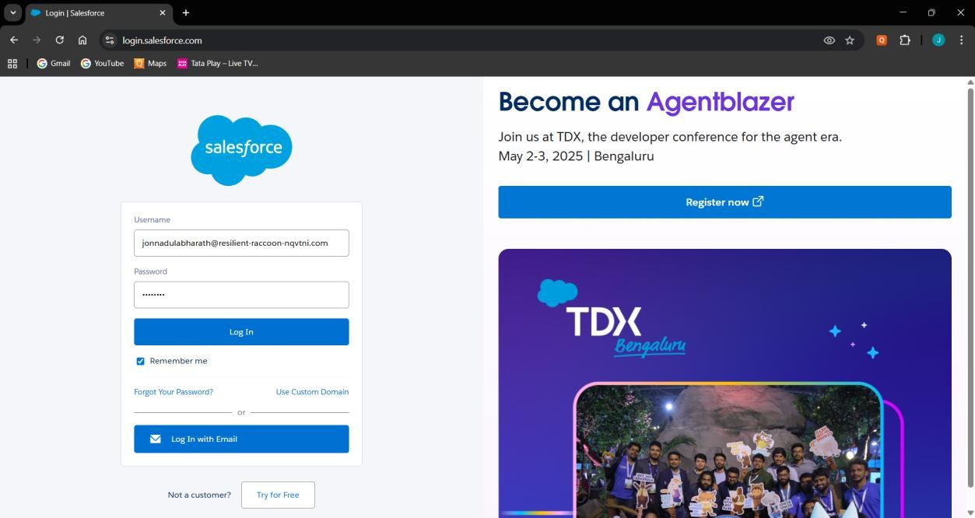

# Company Profile Setup

* + Set Company Name, Currency (INR/USD), and Time Zone.
  + Configure organization-wide defaults.

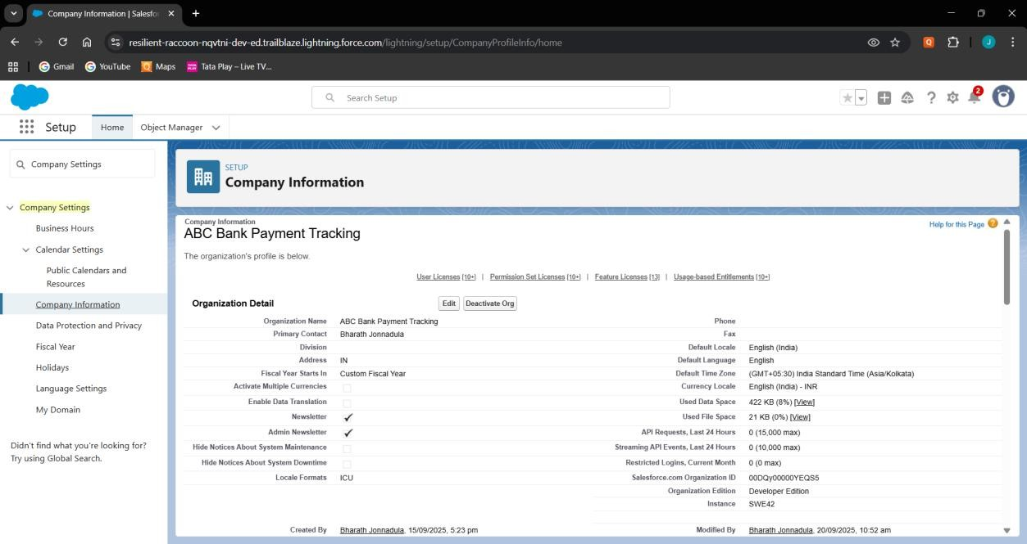

# Business Hours & Holidays

* + Define working hours (e.g., Mon–Sat, 9 AM–6 PM).
  + Add holidays like Independence Day and Diwali.

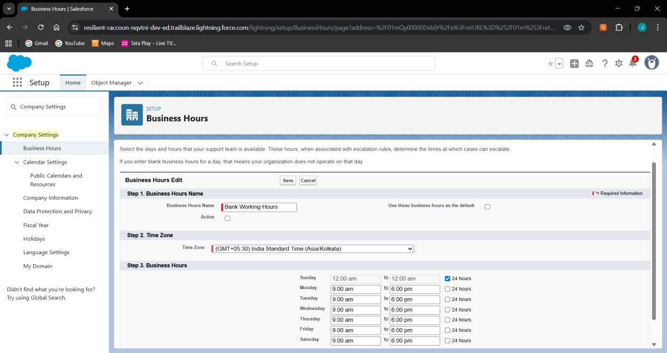

# Fiscal Year Settings

* + Use standard Jan–Dec fiscal year or custom if needed.
  + Align with financial reporting requirements.

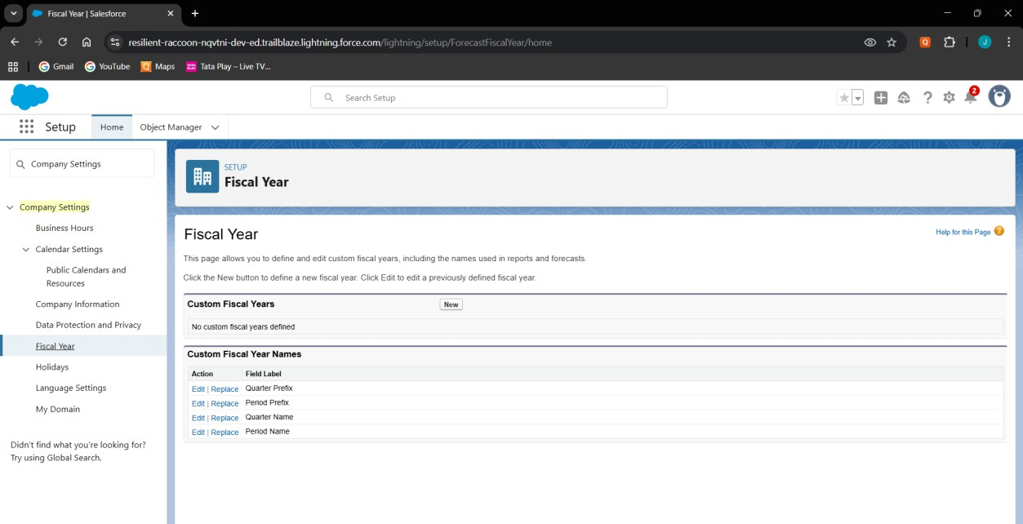

# User Setup & Licenses

* + Create Loan Officer, Recovery Agent, and Manager users.
  + Assign appropriate licenses (Salesforce / Salesforce Platform).

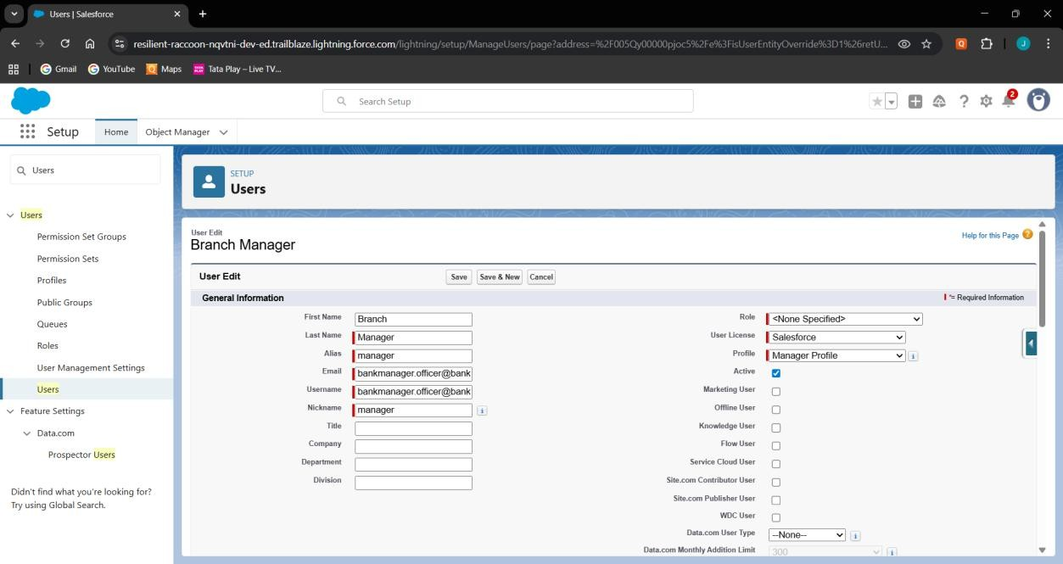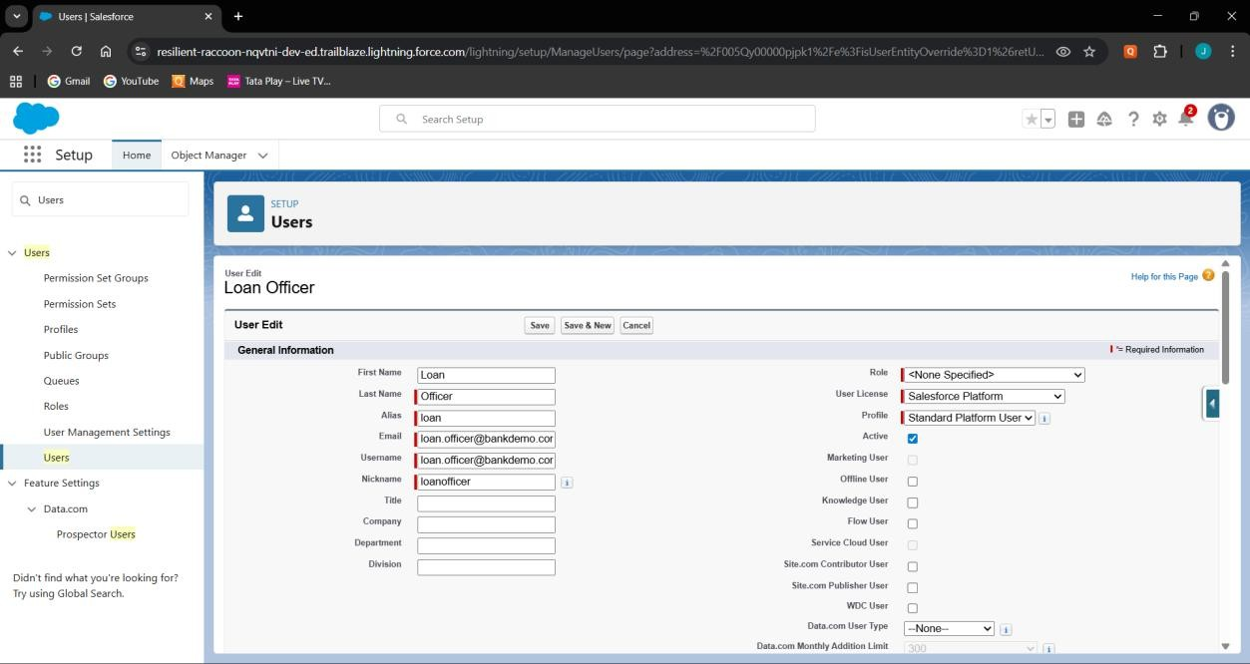

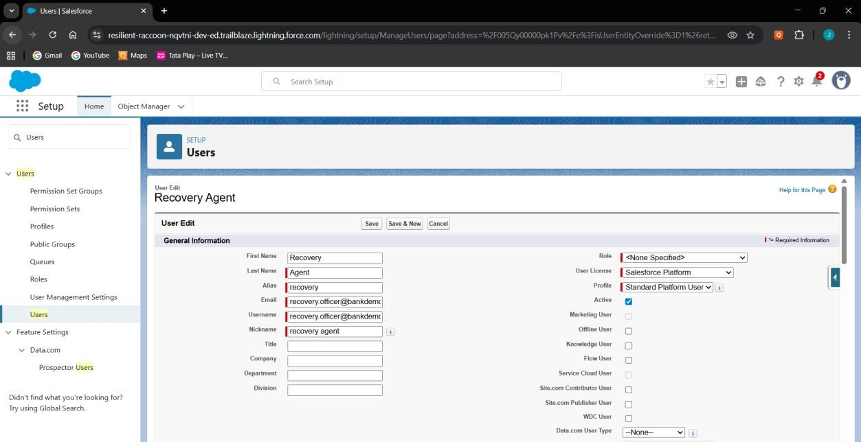

# Profiles & Roles

* + Create custom profiles (Loan Officer, Manager, Recovery Agent).
  + Establish role hierarchy (Manager → Loan Officer / Recovery Agent).

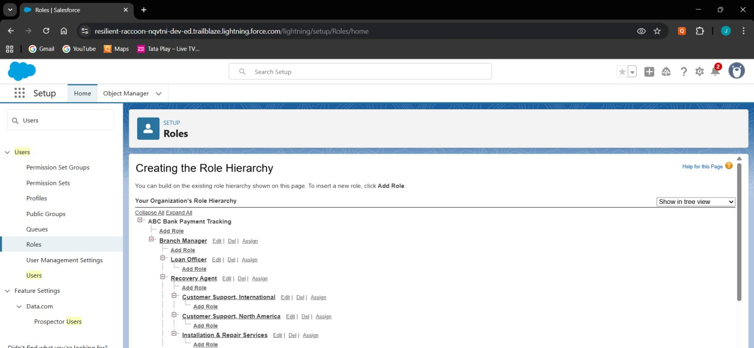

# Permission Sets

* + Create a Permission Set for payment tracking access.
  + Assign Permission Set to Loan Officers and Managers.

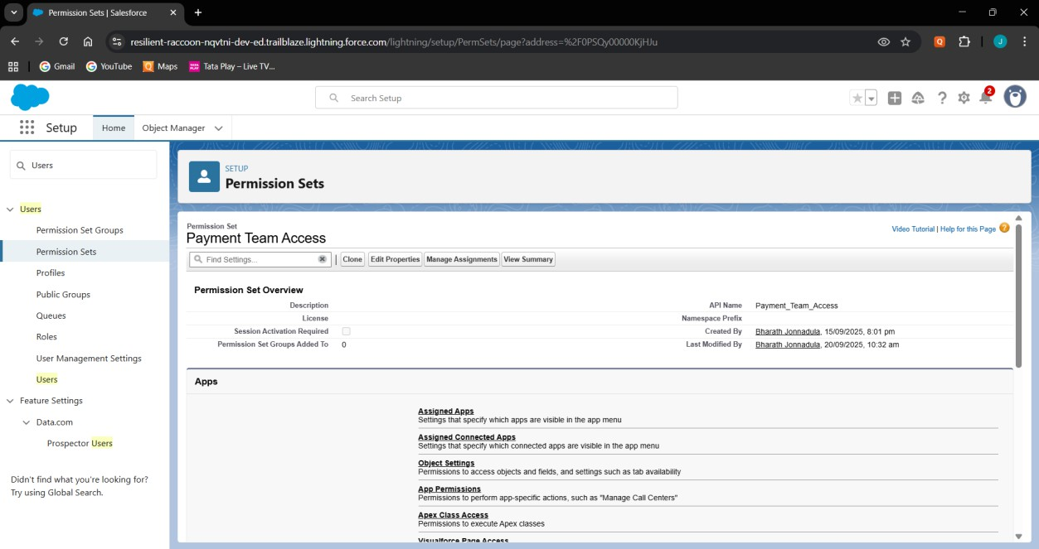

# OWD & Sharing Rules

* + Set custom objects (Loan, Payment, Recovery) to Private.
  + Create rules to share overdue records with Recovery Agents.

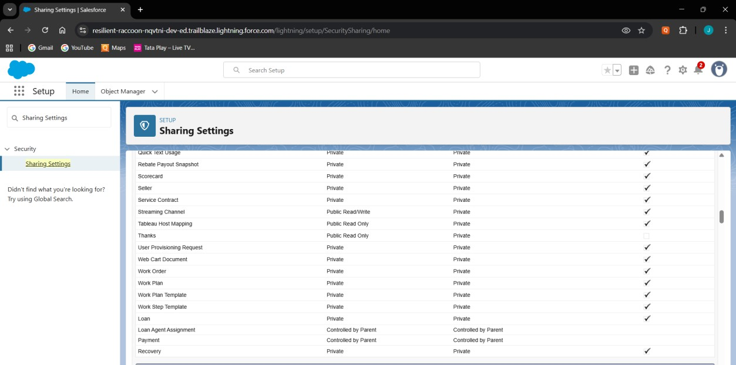

# Login Access Policies

* + Set session timeout to 30 minutes.
  + Enable login hours (8 AM–8 PM) for users.

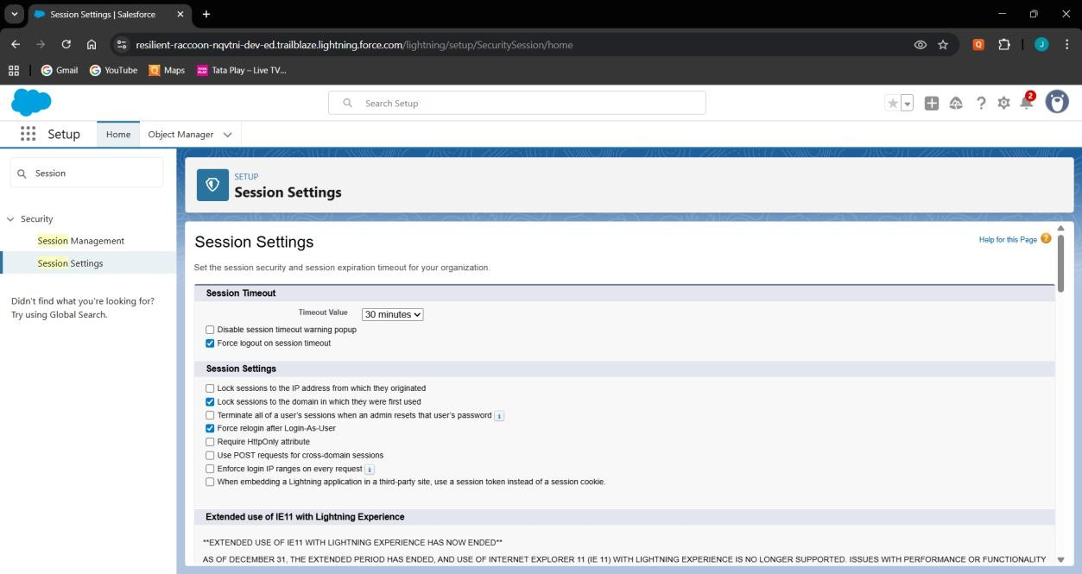

# Dev Org & Sandbox Usage

* + Use Developer Org for development and testing.
  + Plan sandbox usage for production-like testing later.

# Deployment Basics

* + Use SFDX commands to push/pull metadata.
  + Prepare for deployment via Change Sets or SFDX when ready.

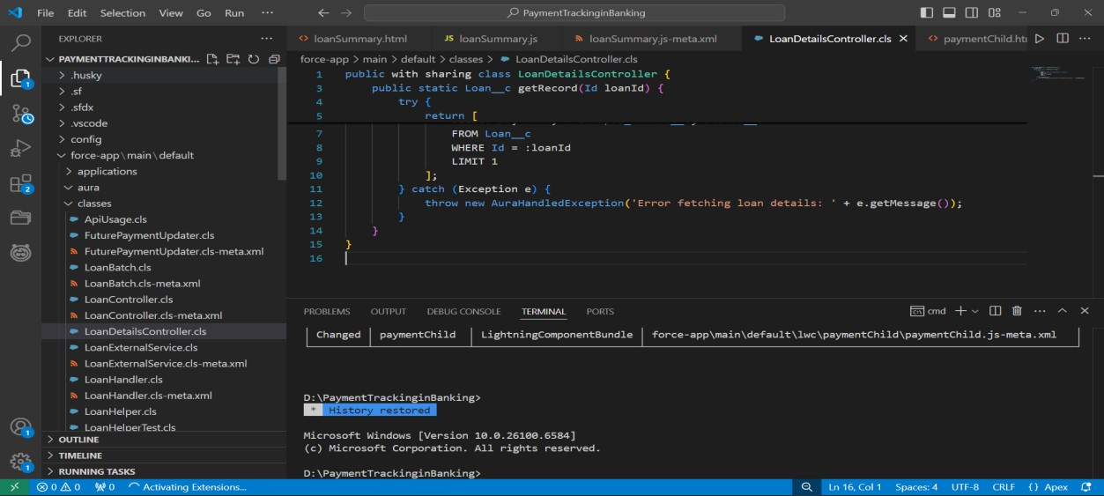

# Phase 3: Data Modeling & Relationships Standard & Custom Objects

* Use Account/Contact for Customers.
* Create custom objects: Loan, Payment, Recovery, Loan Agent Assignment (junction).

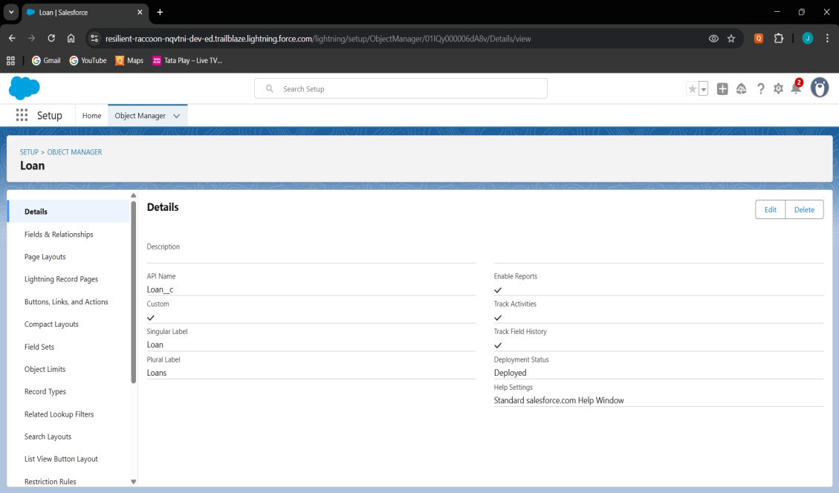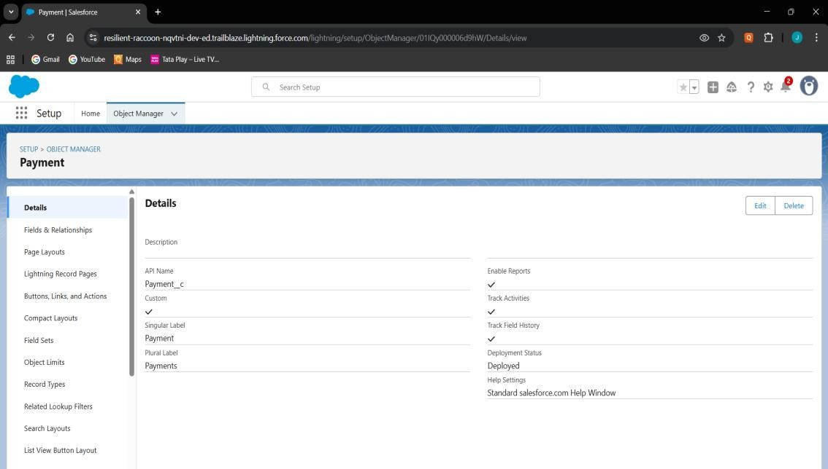

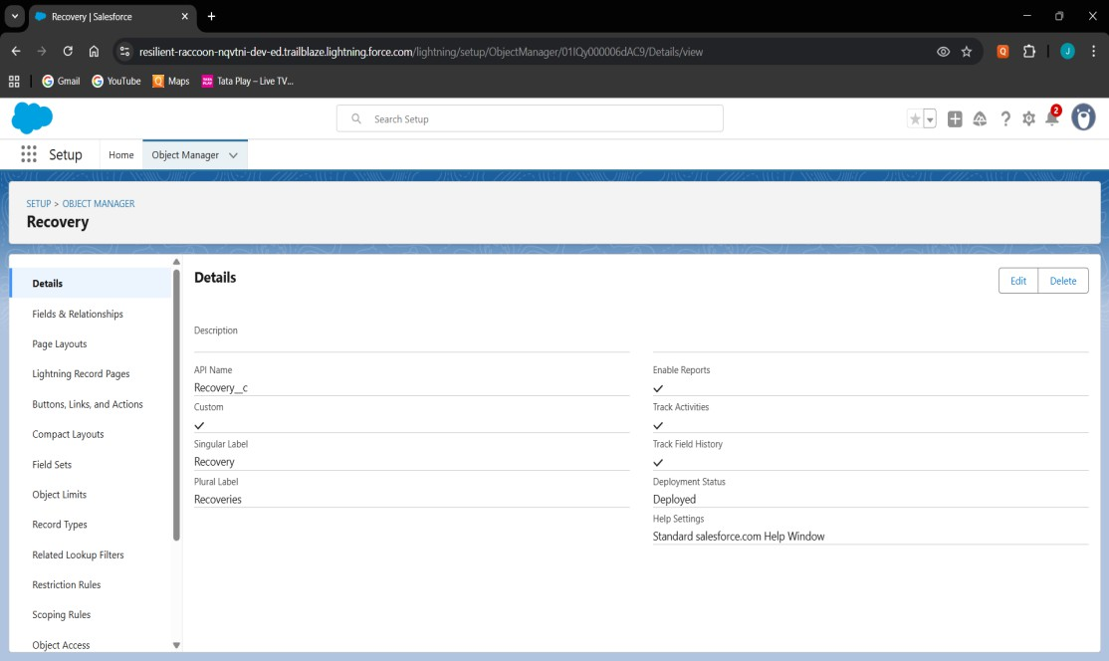

# Fields

* Loan: Loan Number (Auto Number), Principal Amount (Currency), Interest Rate (Percent), Term Months (Number), Start Date (Date), Status (Picklist), Customer (Lookup to Account/Contact).
* Payment: Payment Date (Date), Amount (Currency), Payment Method (Picklist: Cash/UPI/Transfer), Status (Picklist:

Paid/Overdue), Loan (Master-Detail).

* Recovery: Recovery Date (Date), Amount Recovered (Currency), Status (Picklist: Assigned/InProgress/Completed), Loan (Lookup), Assigned Agent (Lookup to User).
* Loan Agent Assignment (junction): Loan (Master-Detail), Assigned Agent (Lookup to User).

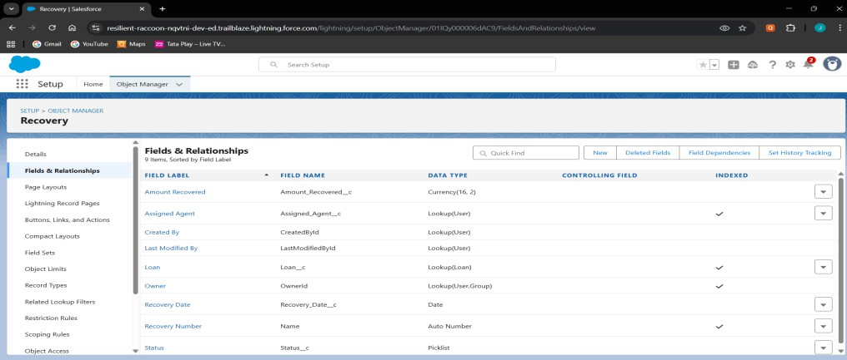

# Record Types

* Loan: Retail Loan & Business Loan.
* Configure Status picklist values per record type (e.g., Retail = Active/Closed, Business = Active/Defaulted).

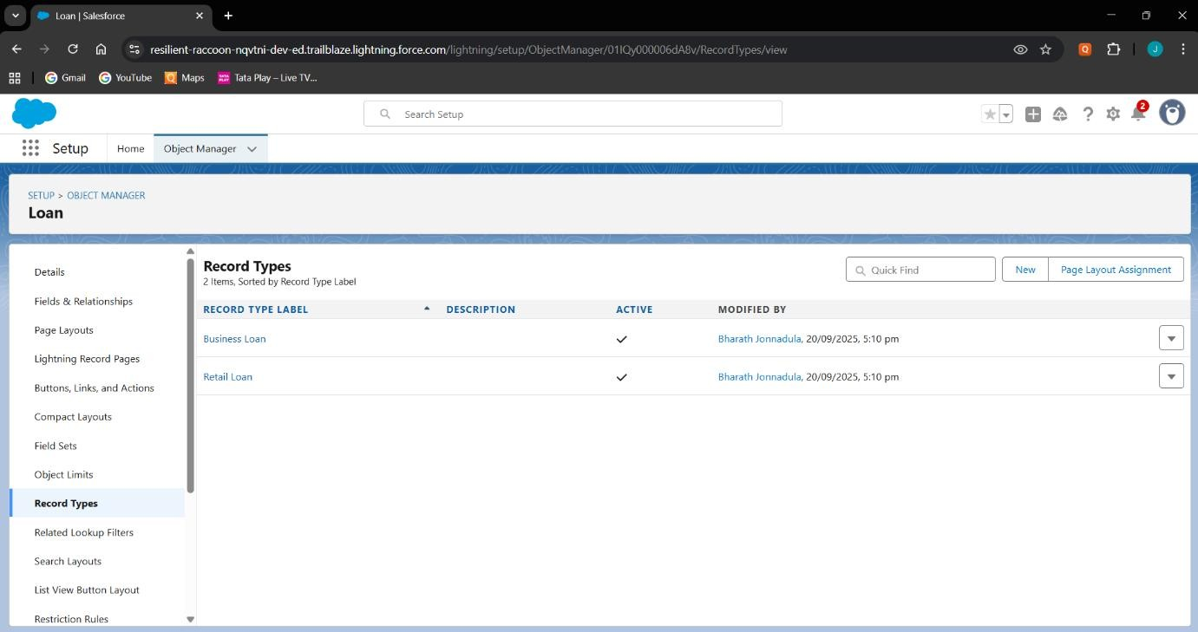

# Page Layouts

* Loan Layout: sections for Basic Info, Financials, Dates & Status. Related Lists = Payments, Recoveries, Loan Agent Assignments.
* Payment Layout: fields for Date, Amount, Method, Status.
* Recovery Layout: fields for Date, Amount Recovered, Status, Assigned Agent.

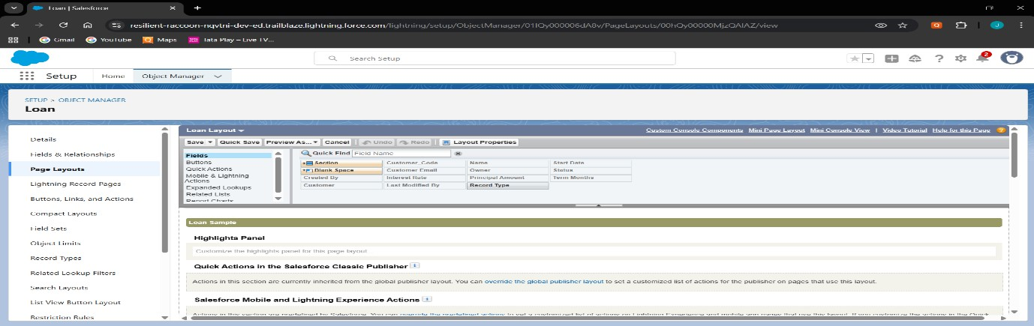

# Compact Layouts

* Loan Compact Layout: Loan Number, Principal Amount, Status, Customer.
* Payment Compact Layout: Payment Date, Amount, Status.
* Recovery Compact Layout: Recovery Date, Amount Recovered, Status.

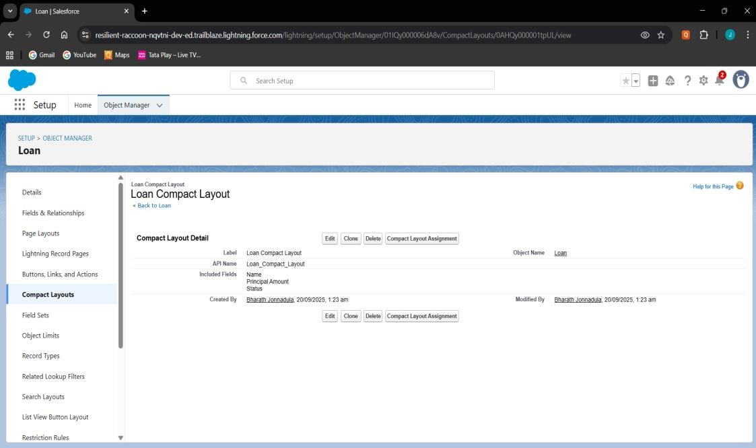

# Schema Builder

* Visualize Loan, Payment, Recovery, and Loan Agent Assignment objects.
* Confirm relationships: Loan–Payment (Master-Detail), Loan–

Recovery (Lookup), Loan–LoanAgentAssignment (Master-Detail), LoanAgentAssignment–User (Lookup).

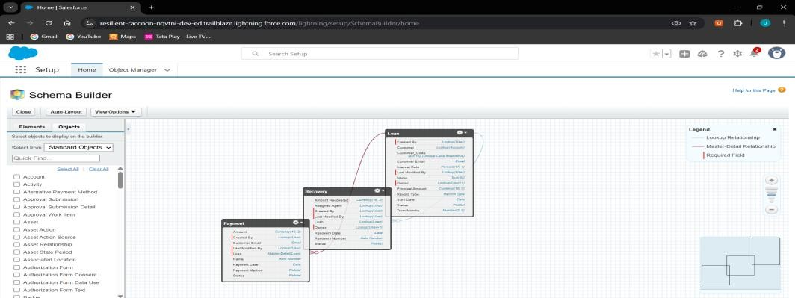

# Lookup vs Master-Detail vs Hierarchical

* Payment → Loan = Master-Detail (payments always tied to loans).
* Recovery → Loan = Lookup (independent audit records).
* Loan Agent Assignment → Loan = Master-Detail, → User = Lookup.
* Hierarchical not used (only for User object).

# Junction Objects

* Loan Agent Assignment to handle many-to-many between Loans and Agents.
* Enables multiple agents handling multiple loans.

# External Objects

* Concept: Connect to external payment system using Salesforce Connect.
* Example: Show legacy payment history without storing inside Salesforce.

# Phase 4: Process Automation (Admin) Validation Rules

* Ensure values are valid (Loan/Payment/Recovery > 0).
* Prevent negative amounts and invalid dates.

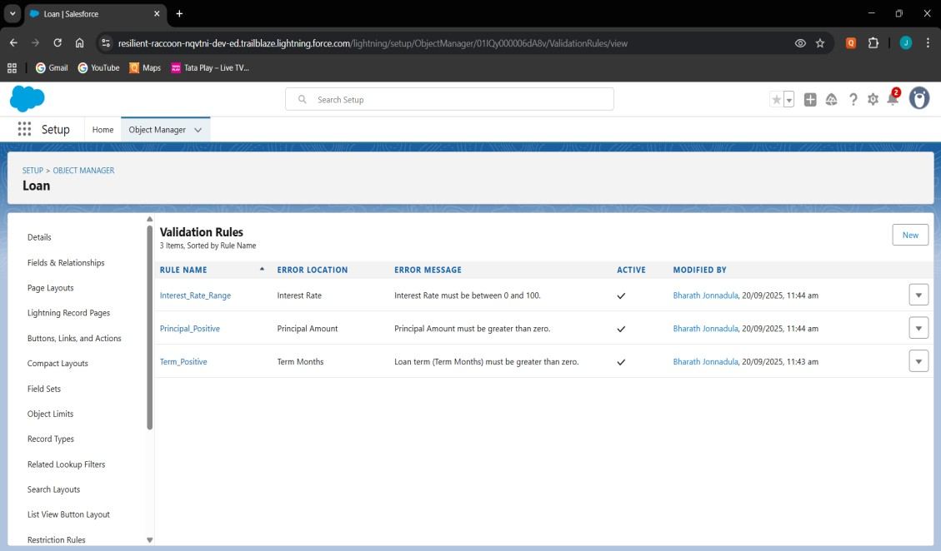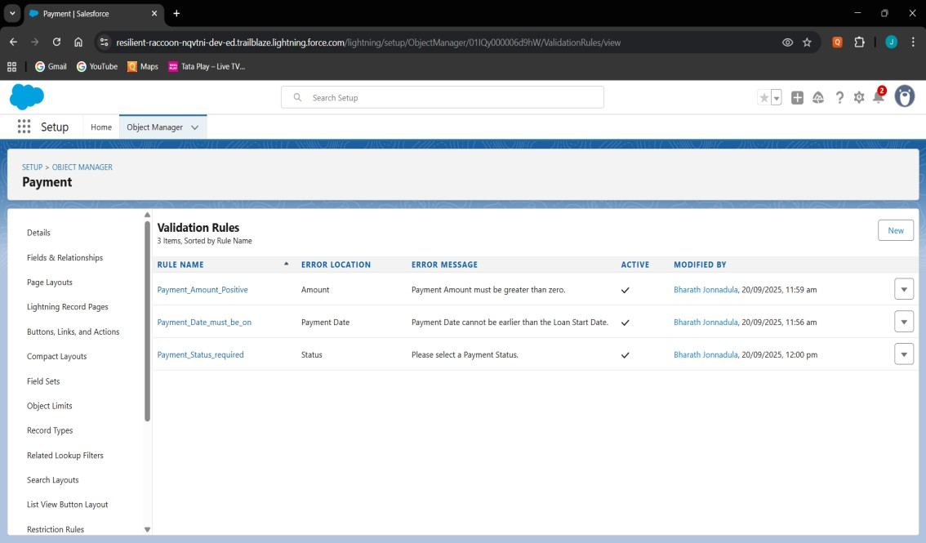

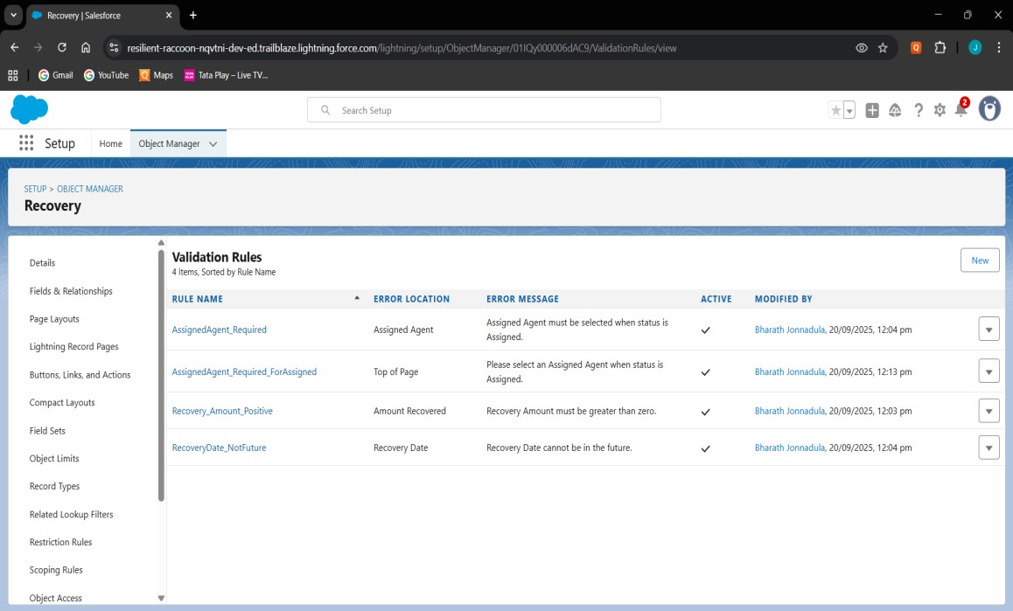

# Workflow Rules

* Rule: Pending_Payment_Reminder.
* 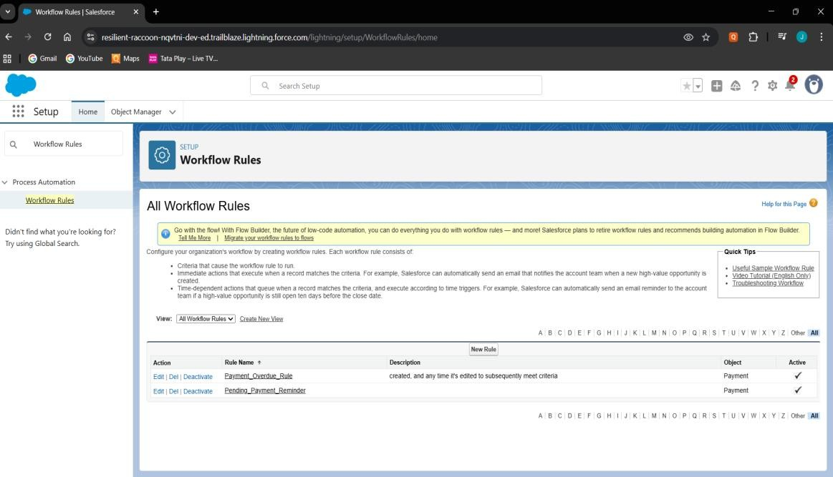Sends reminder email for pending payments.

# Process Builder

* Sends email reminders for due payments.
* Updates Loan status when all Payments are paid.
* Creates follow-up task for overdue payments.

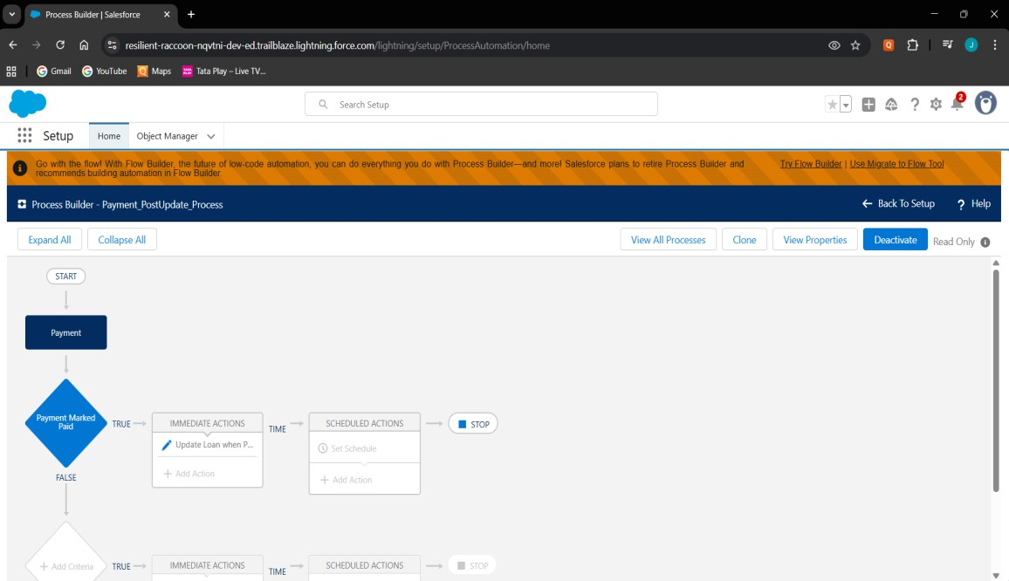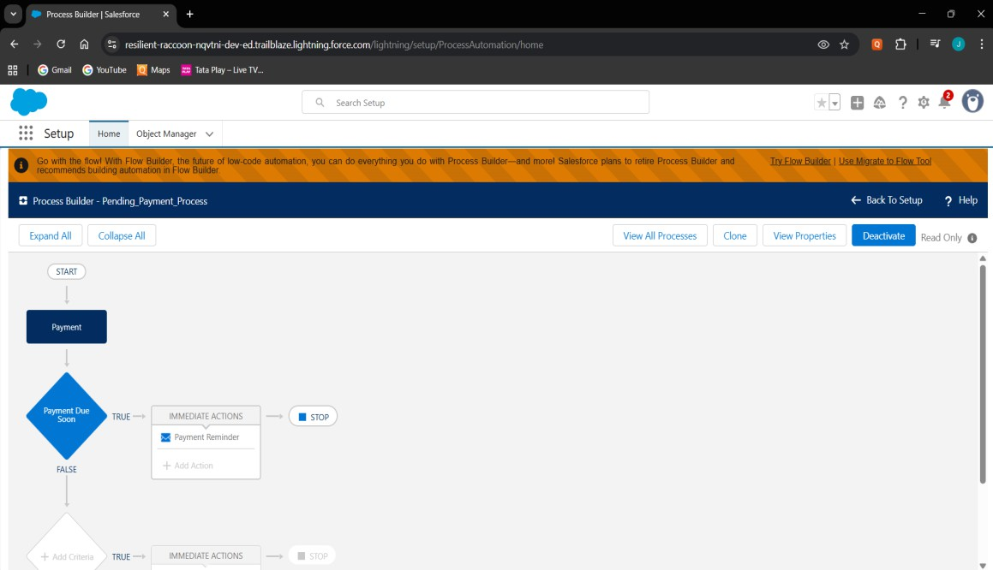

# Approval Process

* Loans > 5 Lakhs require Manager approval.
* Auto email + status update on approval/rejection.

# 

# Flow Builder

* Record-Triggered: Marks payments overdue automatically.
* Record-Triggered: Creates Recovery record when overdue.

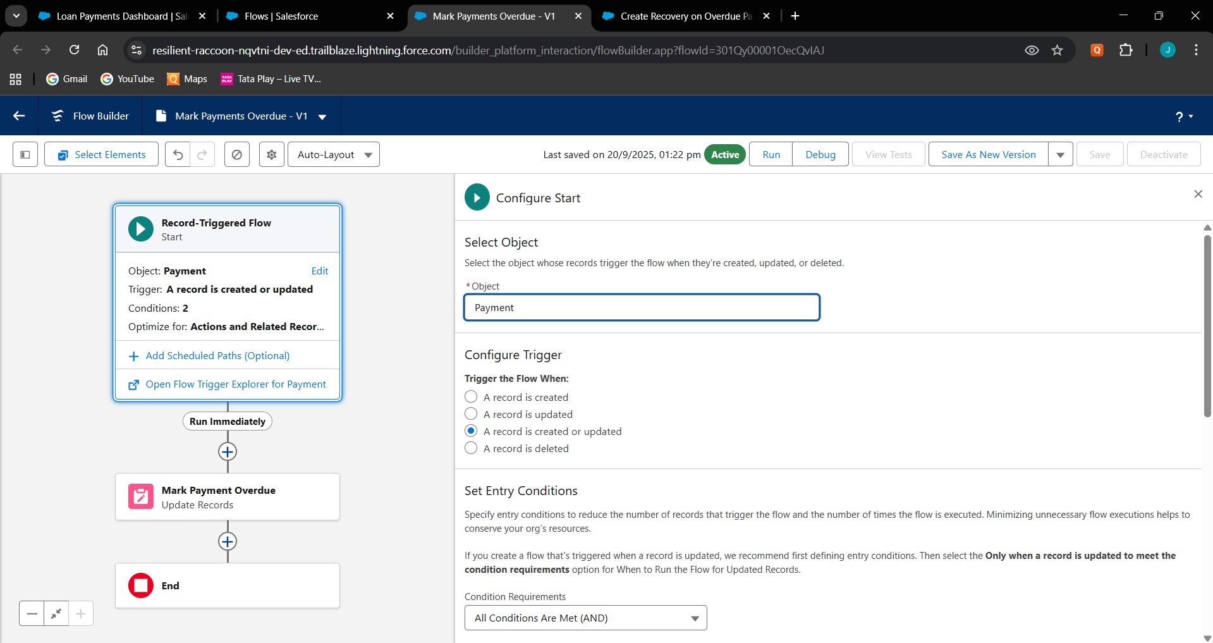**Mark Payments Overdue**

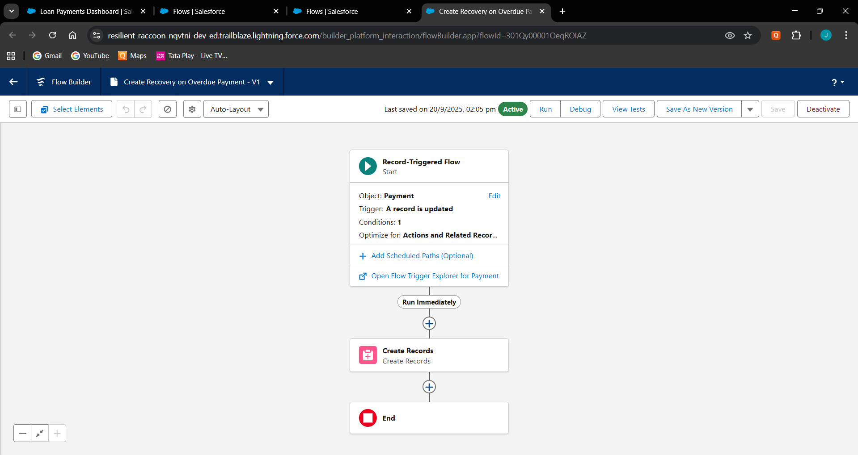**Create Recovery on Overdue**

# Email Alerts

* Payment_Reminder_Email → Customer.
* 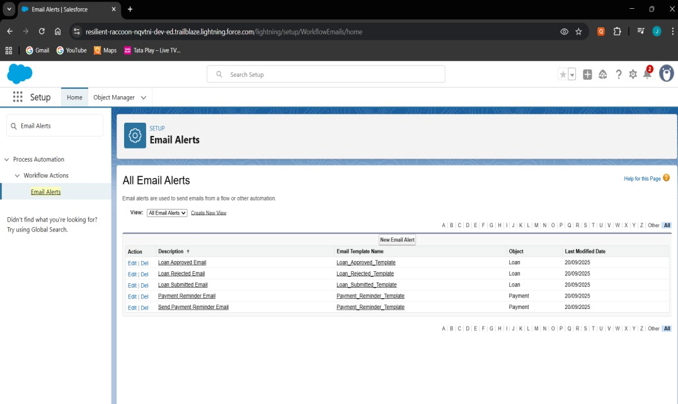Loan_Submitted, Approved, Rejected → Manager/Officer.

# Field Updates

* Auto-change Payment.Status to Overdue.
* 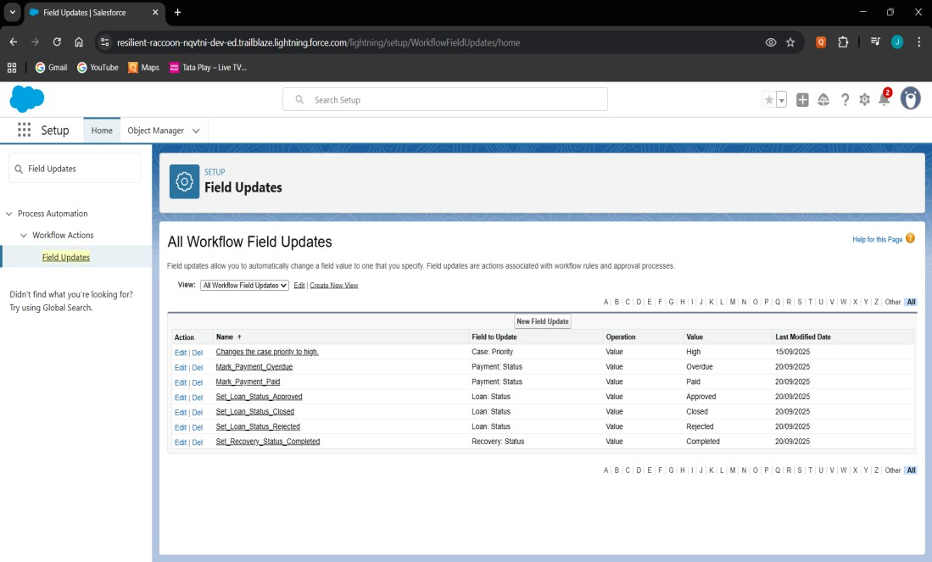Auto-close Loan when all Payments are Paid.

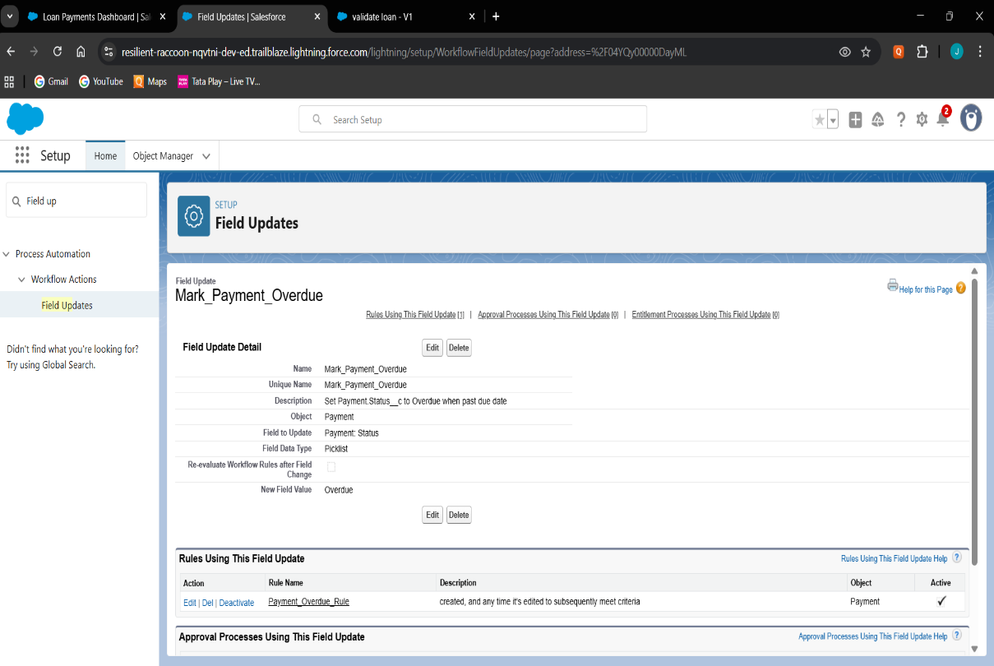

# Tasks

* Task created when Payment is Overdue.
* Assigned to Recovery Agent with high priority.

# Custom Notifications

* Sends in-app notification for Overdue Payments.

# Phase 5: Apex Programming (Developer) Classes & Objects

* Created Apex helper classes (LoanHandler, PaymentHandler, RecoveryHandler) to separate business logic from triggers.
* Used object-oriented approach for cleaner, reusable, and modular code.

**LoanHandler.cls**

public class LoanHandler {

    public static void beforeInsert(List<Loan__c> newLoans) {

        for (Loan__c loan : newLoans) {

            if (loan.Status__c == null) {

                loan.Status__c = 'Pending Approval';

            }

        }

    }

    public static void beforeUpdate(List<Loan__c> newLoans, Map<Id, Loan__c> oldMap) {

        for (Loan__c loan : newLoans) {

            Loan__c oldLoan = oldMap.get(loan.Id);

            if (loan.Principal_Amount__c != oldLoan.Principal_Amount__c) {

                loan.Status__c = 'Modified';

            }

        }

    }

    public static void afterInsert(List<Loan__c> newLoans) {

        System.debug('New Loans inserted: ' + newLoans);

    }

    public static void afterUpdate(List<Loan__c> newLoans, Map<Id, Loan__c> oldMap) {

        System.debug('Loans updated: ' + newLoans);

    }

    public static void afterDelete(List<Loan__c> oldLoans) {

        System.debug('Loans deleted: ' + oldLoans);

    }

}

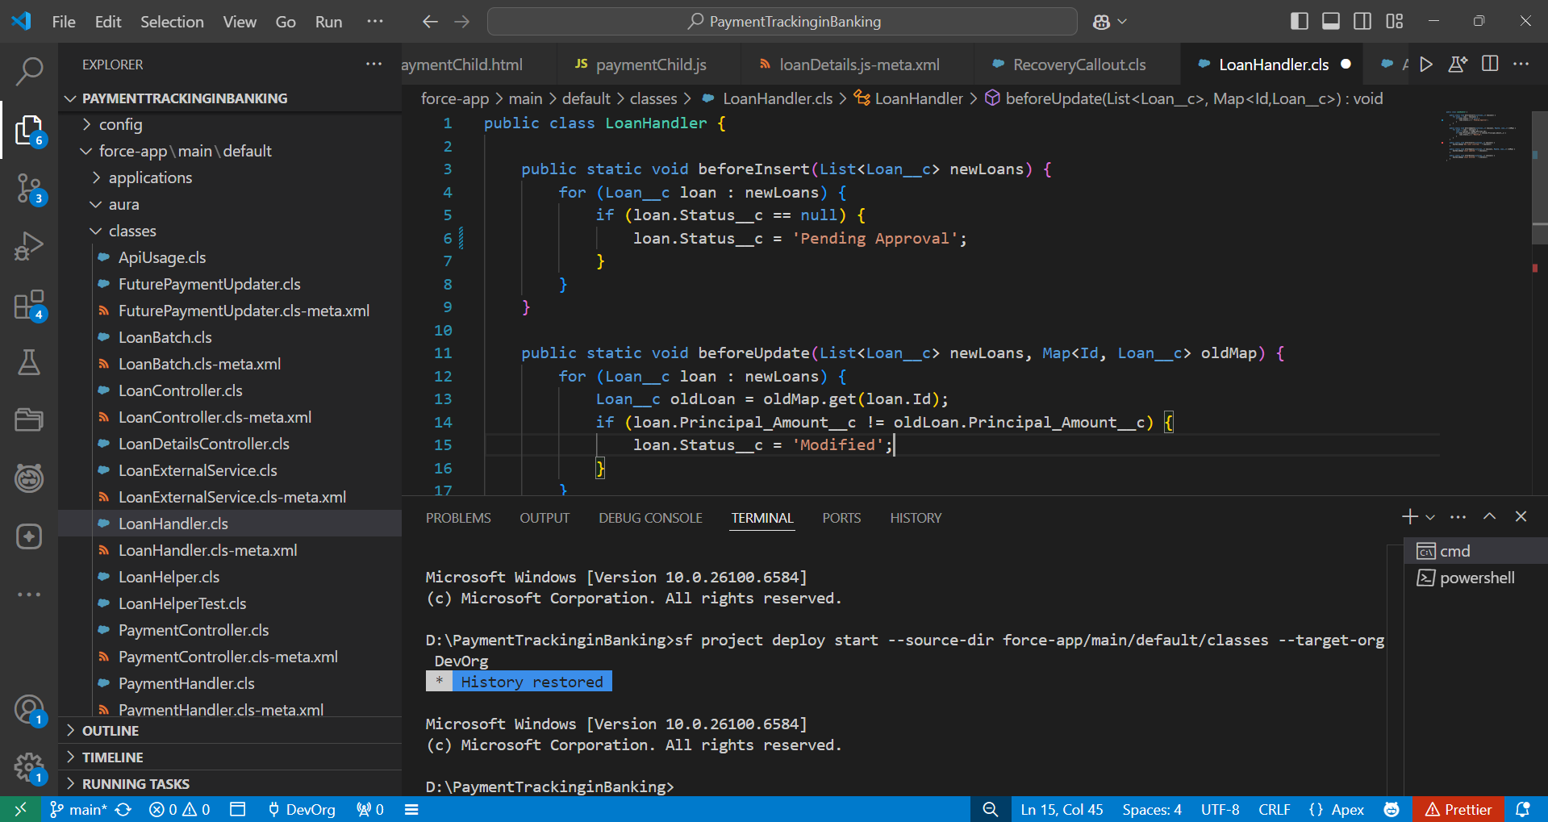

**PaymentHandler.cls**

public class PaymentHandler {

    public static void beforeInsert(List<Payment__c> newPayments) {

        for (Payment__c p : newPayments) {

            if (p.Status__c == null) p.Status__c = 'Pending';

        }

    }

    public static void beforeUpdate(List<Payment__c> newPayments, Map<Id, Payment__c> oldMap) {

        for (Payment__c p : newPayments) {

            Payment__c oldP = oldMap.get(p.Id);

            if (p.Amount__c != oldP.Amount__c) {

                p.Status__c = 'Revised';

            }

        }

    }

    public static void afterInsert(List<Payment__c> newPayments) {

        updateLoanStatus(newPayments);

    }

    public static void afterUpdate(List<Payment__c> newPayments, Map<Id, Payment__c> oldMap) {

        updateLoanStatus(newPayments);

    }

    public static void afterDelete(List<Payment__c> oldPayments) {

        updateLoanStatus(oldPayments);

    }

    private static void updateLoanStatus(List<Payment__c> payments) {

        Set<Id> loanIds = new Set<Id>();

        for (Payment__c p : payments) if (p.Loan__c != null) loanIds.add(p.Loan__c);

        if (loanIds.isEmpty()) return;

        Map<Id, Integer> totalPayments = new Map<Id, Integer>();

        for (AggregateResult ar : [

            SELECT Loan__c loanId, COUNT(Id) totalCount

            FROM Payment__c WHERE Loan__c IN :loanIds

            GROUP BY Loan__c

        ]) {

            totalPayments.put((Id) ar.get('loanId'), (Integer) ar.get('totalCount'));

        }

        Map<Id, Integer> paidPayments = new Map<Id, Integer>();

        for (AggregateResult ar : [

            SELECT Loan__c loanId, COUNT(Id) paidCount

            FROM Payment__c WHERE Loan__c IN :loanIds AND Status__c = 'Paid'

            GROUP BY Loan__c

        ]) {

            paidPayments.put((Id) ar.get('loanId'), (Integer) ar.get('paidCount'));

        }

        List<Loan__c> loansToUpdate = new List<Loan__c>();

        for (Id lid : loanIds) {

            Integer total = totalPayments.containsKey(lid) ? totalPayments.get(lid) : 0;

            Integer paid = paidPayments.containsKey(lid) ? paidPayments.get(lid) : 0;

            if (total > 0 && total == paid) {

                loansToUpdate.add(new Loan__c(Id = lid, Status__c = 'Closed'));

            } else {

                loansToUpdate.add(new Loan__c(Id = lid, Status__c = 'Active'));

            }

        }

        if (!loansToUpdate.isEmpty()) update loansToUpdate;

    }

}

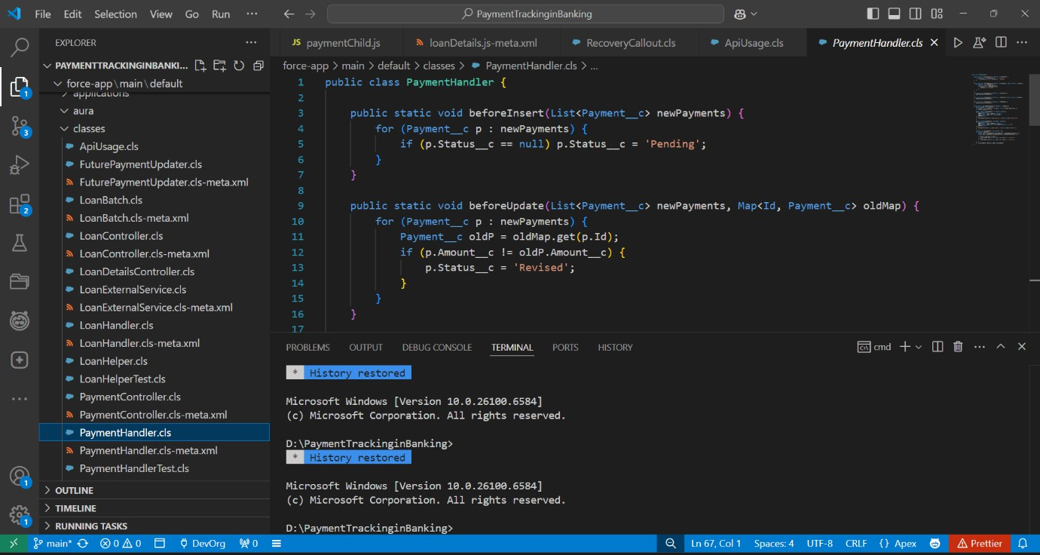

**RecoveryHandler.cls**

public class RecoveryHandler {

    public static void beforeInsert(List<Recovery__c> newRecoveries) {

        for (Recovery__c r : newRecoveries) {

            if (r.Status__c == null) r.Status__c = 'Assigned';

        }

    }

    public static void beforeUpdate(List<Recovery__c> newRecoveries, Map<Id, Recovery__c> oldMap) {

        for (Recovery__c r : newRecoveries) {

            Recovery__c oldR = oldMap.get(r.Id);

            if (r.Amount_Recovered__c != oldR.Amount_Recovered__c) {

                r.Status__c = 'Updated';

            }

        }

    }

    public static void afterInsert(List<Recovery__c> newRecoveries) {

        System.debug('New Recoveries: ' + newRecoveries);

    }

    public static void afterUpdate(List<Recovery__c> newRecoveries, Map<Id, Recovery__c> oldMap) {

        System.debug('Updated Recoveries: ' + newRecoveries);

    }

    public static void afterDelete(List<Recovery__c> oldRecoveries) {

        System.debug('Deleted Recoveries: ' + oldRecoveries);

    }

}

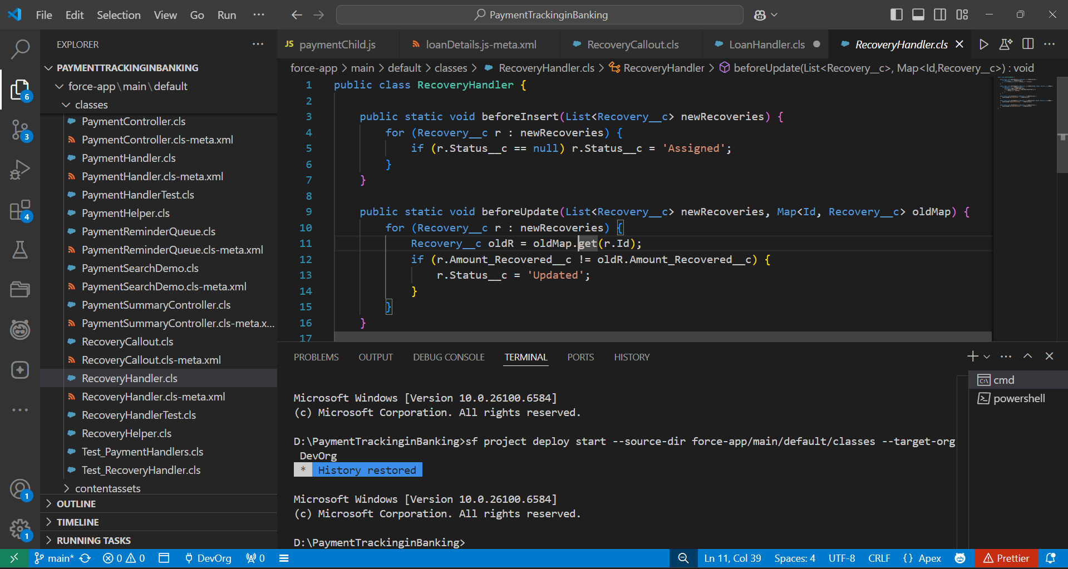

# Apex Triggers

* Implemented triggers for Loan, Payment, and Recovery to handle automation like updating statuses and roll-ups.

**LoanTrigger.trigger**

trigger LoanTrigger on Loan__c (

    before insert, before update,

    after insert, after update, after delete

) {

    if (Trigger.isBefore) {

        if (Trigger.isInsert) LoanHandler.beforeInsert(Trigger.new);

        if (Trigger.isUpdate) LoanHandler.beforeUpdate(Trigger.new, Trigger.oldMap);

    }

    if (Trigger.isAfter) {

        if (Trigger.isInsert) LoanHandler.afterInsert(Trigger.new);

        if (Trigger.isUpdate) LoanHandler.afterUpdate(Trigger.new, Trigger.oldMap);

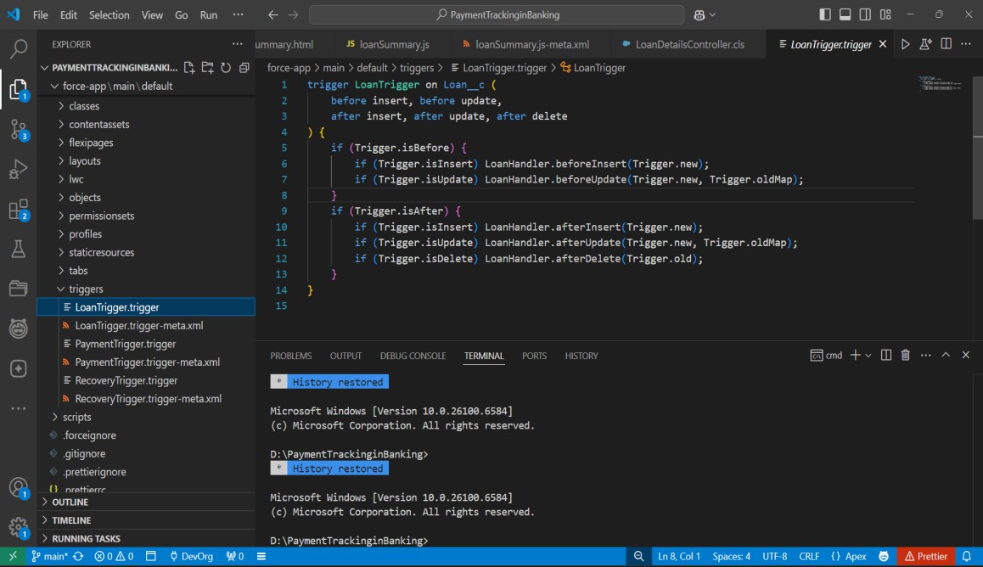        if (Trigger.isDelete) LoanHandler.afterDelete(Trigger.old);}}}

**PaymentTrigger.trigger**

trigger PaymentTrigger on Payment__c (

    before insert, before update,

    after insert, after update, after delete

) {

    if (Trigger.isBefore) {

        if (Trigger.isInsert) PaymentHandler.beforeInsert(Trigger.new);

        if (Trigger.isUpdate) PaymentHandler.beforeUpdate(Trigger.new, Trigger.oldMap);

    }

    if (Trigger.isAfter) {

        if (Trigger.isInsert) PaymentHandler.afterInsert(Trigger.new);

        if (Trigger.isUpdate) PaymentHandler.afterUpdate(Trigger.new, Trigger.oldMap);

        if (Trigger.isDelete) PaymentHandler.afterDelete(Trigger.old);

    }

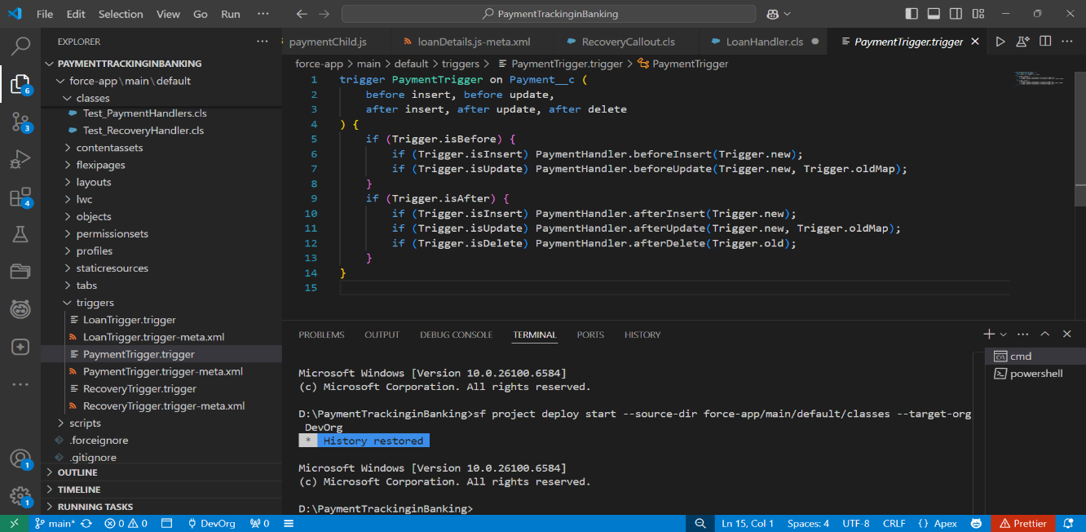}

**RecoveryTrigger.trigger**

trigger RecoveryTrigger on Recovery__c (

    before insert, before update,

    after insert, after update, after delete

) {

    if (Trigger.isBefore) {

        if (Trigger.isInsert) RecoveryHandler.beforeInsert(Trigger.new);

        if (Trigger.isUpdate) RecoveryHandler.beforeUpdate(Trigger.new, Trigger.oldMap);

    }

    if (Trigger.isAfter) {

        if (Trigger.isInsert) RecoveryHandler.afterInsert(Trigger.new);

        if (Trigger.isUpdate) RecoveryHandler.afterUpdate(Trigger.new, Trigger.oldMap);

        if (Trigger.isDelete) RecoveryHandler.afterDelete(Trigger.old);

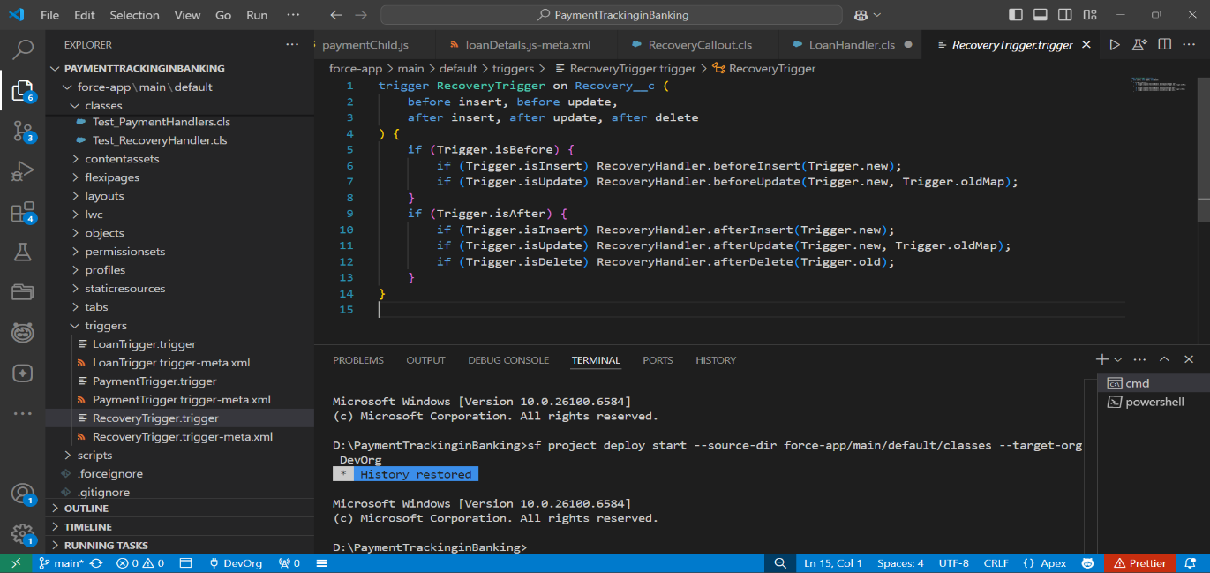    }}

# Trigger Design Pattern

* Applied Trigger Handler Pattern to keep trigger code clean and delegate logic to handler classes.
* 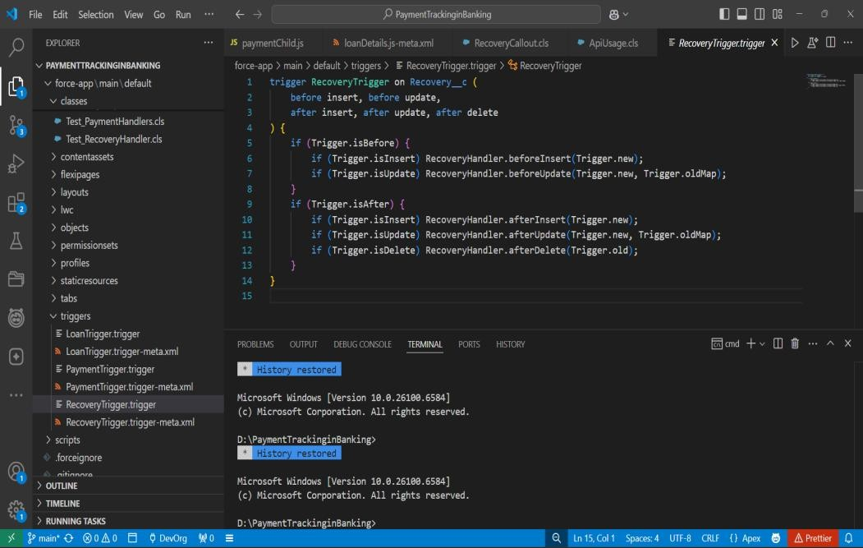Ensured only one trigger per object with proper event handling.

# SOQL & SOSL

* Used SOQL in classes to query Loans, Payments, and Recoveries.
* Implemented simple search functionality to fetch customer records.

**LoanDetailsController.cls**

public with sharing class LoanController {

    @AuraEnabled(cacheable=true)

    public static Loan__c getLoan(String loanId) {

      return [SELECT  Name, Principal_Amount__c FROM Loan__c WHERE Id = :loanId LIMIT 1];

    }

@AuraEnabled

    public static Boolean markLoanClosed(String loanId) {

      try {

        Loan__c L = [SELECT Id, Status__c FROM Loan__c WHERE Id = :loanId LIMIT 1];

        L.Status__c = 'Closed';

        update L;

        return true;

      } catch (Exception e) {

        throw new AuraHandledException('Cannot close loan: ' + e.getMessage());

      }

    }

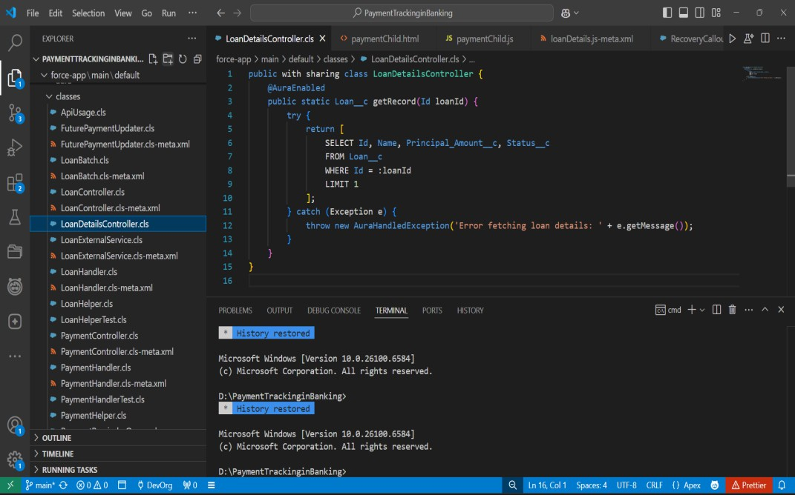  }

**PaymentsController.cls**

public class PaymentController {

    @AuraEnabled(cacheable=true)

    public static List<Payment__c> getPayments(Id loanId) {

        if (loanId == null) return new List<Payment__c>();

        return [

            SELECT Name, Amount__c, Status__c, Payment_Date__c

            FROM Payment__c

            WHERE Loan__c = :loanId

            ORDER BY Payment_Date__c DESC

];

}

}

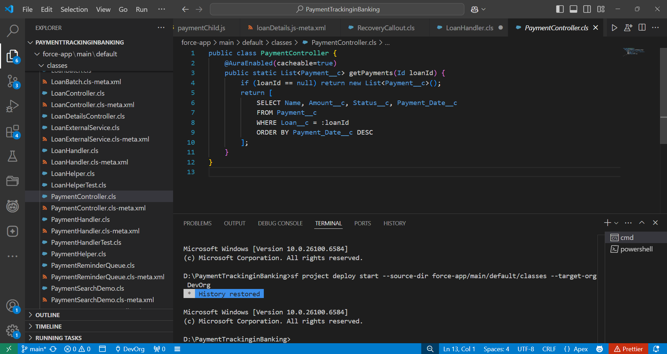

# Collections: List, Set, Map

* Applied Lists to hold multiple Payments for bulk processing.
* Used Maps for Loan → Payments mapping to handle roll-ups efficiently.

**PaymentRemainderQueue.cls**

public class PaymentReminderQueue implements Queueable {

    public void execute(QueueableContext context) {

        List<Payment__c> duePayments = [

            SELECT Id, Status__c FROM Payment__c WHERE Status__c = 'Pending'

        ];

        for (Payment__c p : duePayments) {

            p.Status__c = 'Reminder Sent';

        }

        update duePayments;

        System.debug(' Queue Job executed for reminders.');

    }

}

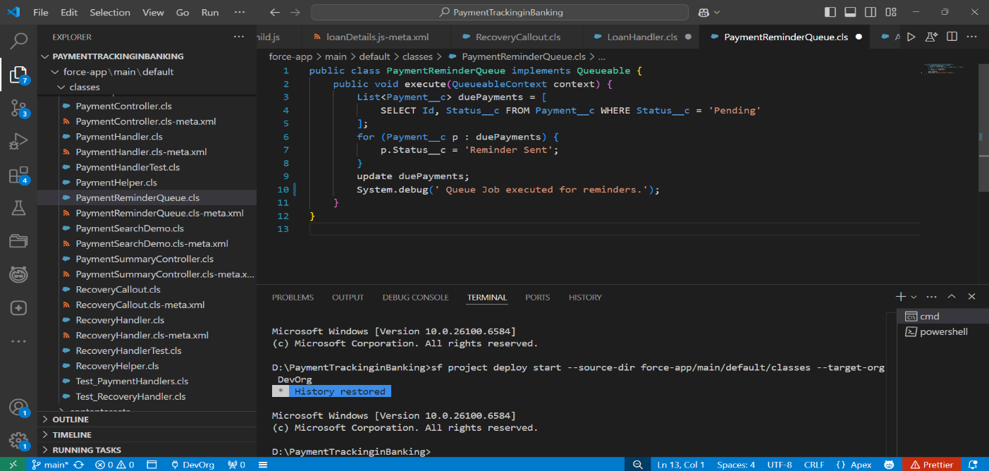

# Control Statements

* Implemented IF conditions for validation.

**RecoveryHandler.cls**

public class RecoveryHandler {

    public static void beforeInsert(List<Recovery__c> newRecoveries) {

        for (Recovery__c r : newRecoveries) {

            if (r.Status__c == null) r.Status__c = 'Assigned';

        }

    }

    public static void beforeUpdate(List<Recovery__c> newRecoveries, Map<Id, Recovery__c> oldMap) {

        for (Recovery__c r : newRecoveries) {

            Recovery__c oldR = oldMap.get(r.Id);

            if (r.Amount_Recovered__c != oldR.Amount_Recovered__c) {

                r.Status__c = 'Updated';

            }

        }

    }

    public static void afterInsert(List<Recovery__c> newRecoveries) {

        System.debug('New Recoveries: ' + newRecoveries);

    }

public static void afterUpdate(List<Recovery__c> newRecoveries, Map<Id, Recovery__c> oldMap) {

        System.debug('Updated Recoveries: ' + newRecoveries);

    }

    public static void afterDelete(List<Recovery__c> oldRecoveries) {

        System.debug('Deleted Recoveries: ' + oldRecoveries);

    }

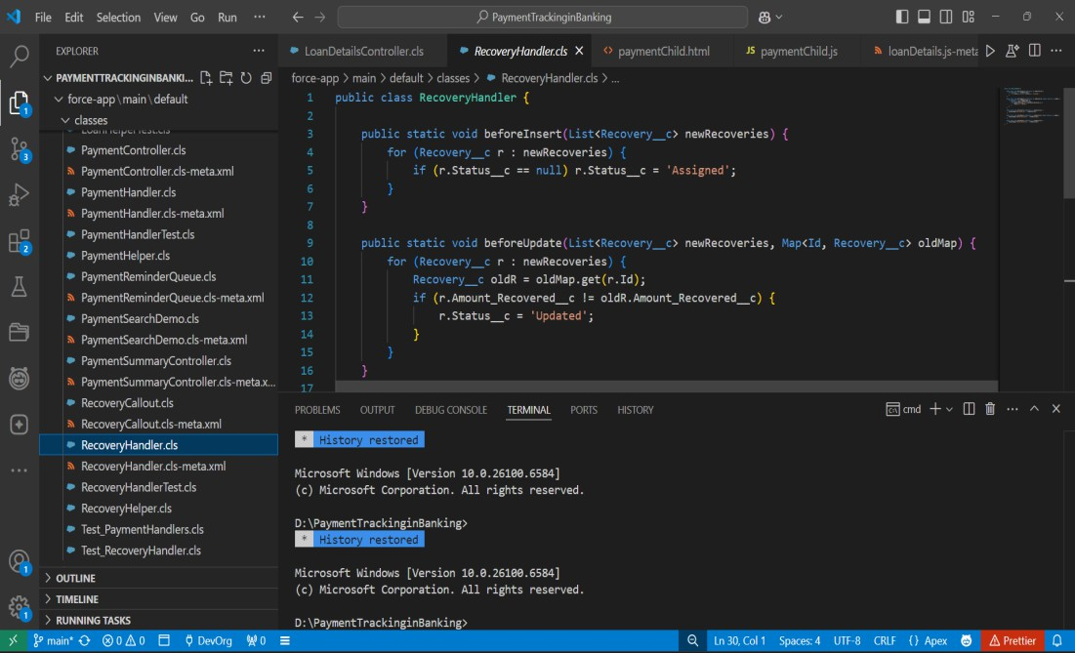}

# Batch Apex

* Created simple batch class for recalculating loan balances.
* Enabled processing of large datasets asynchronously.

**LoanBatch.cls**

global class LoanBatch implements Database.Batchable<sObject> {

    global Database.QueryLocator start(Database.BatchableContext bc) {

        return Database.getQueryLocator('SELECT Id, Status__c FROM Loan__c WHERE Status__c = \'Active\'');

    }

    global void execute(Database.BatchableContext bc, List<Loan__c> scope) {

        for (Loan__c l : scope) {

            l.Status__c = 'Closed';

        }

        update scope;

    }

    global void finish(Database.BatchableContext bc) {

        System.debug(' Loan Batch finished updating loans.');

    }

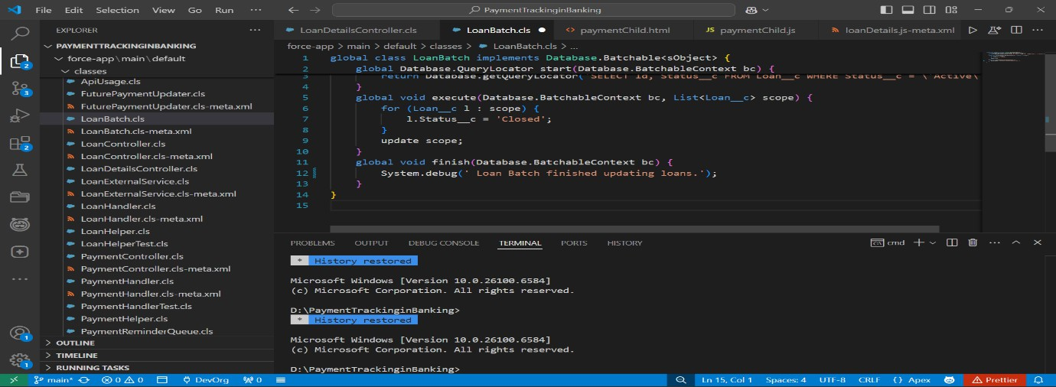}

# Queueable Apex

* Used Queueable Apex for lightweight async operations like notifications.
* 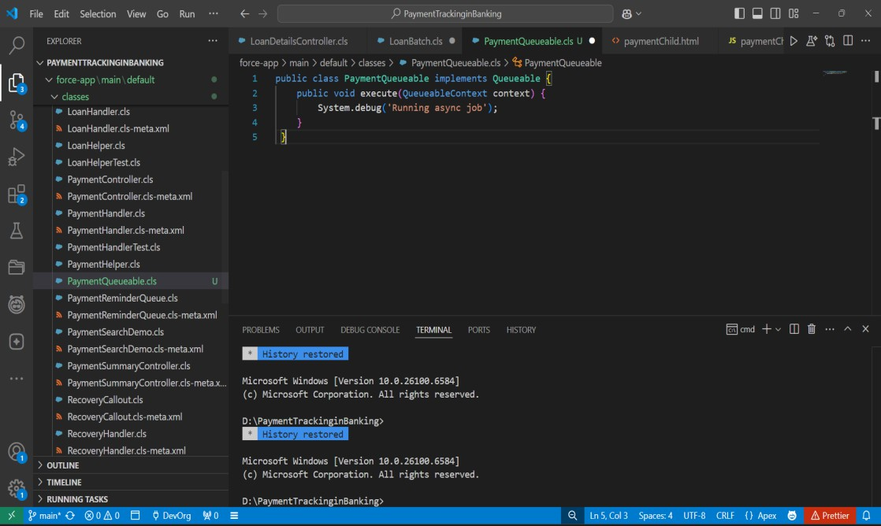Provides better chaining support compared to future methods.

# Scheduled Apex

* Built a scheduler to run daily overdue payment checks.
* Automated reminders and recovery creation without manual intervention.

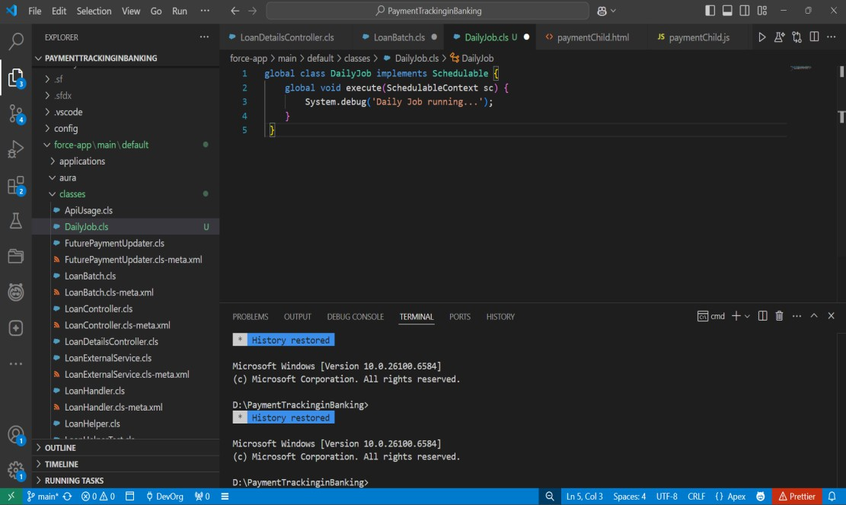

# Future Methods

* Implemented future call for sending async email notifications.

# Exception Handling

* Created a centralized ErrorHandler class to log and handle exceptions.
* Ensured smooth error reporting without stopping automation.

**LoanHelper.cls**

public class LoanHelper {

    public static void beforeInsert(List<Loan__c> newLoans) {

        try {

            for (Loan__c loan : newLoans) {

                if (loan.Amount__c <= 0) {

                    throw new PaymentTrackingException('Loan Amount must be greater than 0.');

                }

            }

        } catch (Exception ex) {

            String msg = ErrorHandler.logError(ex, 'LoanHelper.beforeInsert');

            ErrorHandler.notifyAdmin('Loan Insert Error', msg);

            throw ex;

        }

    }

}

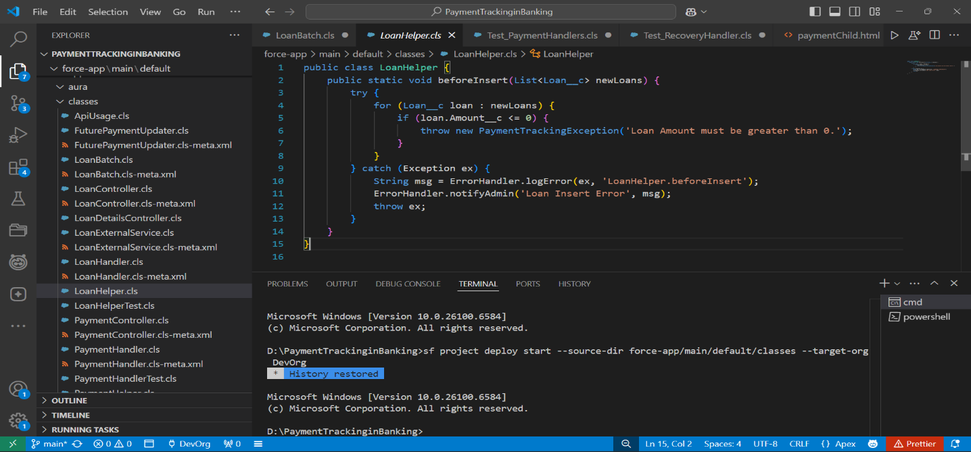

**PaymentHelper.cls**

public class PaymentHandler {

    public static void beforeInsert(List<Payment__c> newPayments) {

        try {

            for (Payment__c pay : newPayments) {

                if (pay.Payment_Date__c == null) {

                    throw new PaymentTrackingException('Payment Date is required.');

                }

            }

        } catch (Exception ex) {

            String msg = ErrorHandler.logError(ex, 'PaymentHandler.beforeInsert');

            ErrorHandler.notifyAdmin('Payment Insert Error', msg);

            throw ex;

        }

    }

    public static void afterUpdate(List<Payment__c> updatedPayments) {

        try {

for (Payment__c pay : updatedPayments) {

                if (pay.Status__c == 'Overdue') {

                    System.debug('Payment ' + pay.Id + ' is overdue. Creating recovery...');

                }

            }

        } catch (Exception ex) {

            String msg = ErrorHandler.logError(ex, 'PaymentHandler.afterUpdate');

            ErrorHandler.notifyAdmin('Payment Update Error', msg);

        }

    }

}

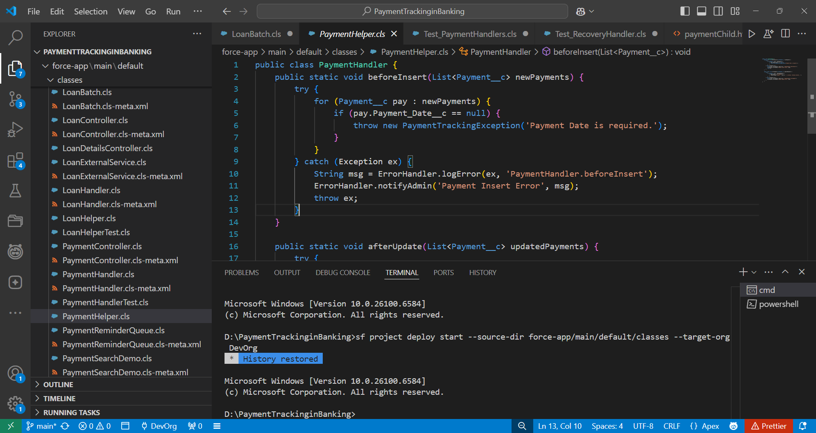

# Test Classes

* Wrote test classes for each handler & trigger to validate functionality.

**LoanHelperTest.cls**

@isTest

public class LoanHelperTest {

    @isTest

    static void testLoanBeforeInsert() {

        Loan__c loan = new Loan__c(

            Principal_Amount__c = 50000,

            Term_Months__c = 12,

            Interest_Rate__c = 10

        );

        Test.startTest();

        insert loan;

        Test.stopTest();

        System.assertNotEquals(null, loan.Id);

    }

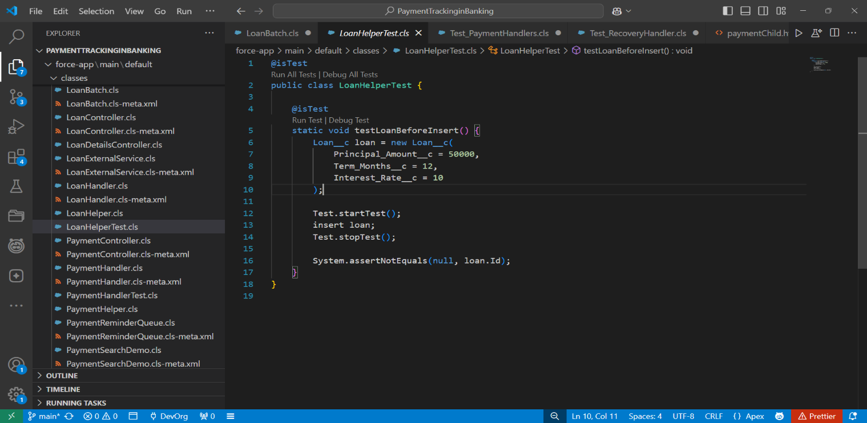}

**Test_PaymentHandlers.cls**

@IsTest

private class Test_PaymentHandlers {

    @IsTest static void testPaymentInsertAndLoanClose() {

        Loan__c loan = new Loan__c(Name='TestLoan', Principal_Amount__c = 1000.00, Status__c='Active');

        insert loan;

        Payment__c p1 = new Payment__c(Name='P1', Loan__c = loan.Id, Payment_Date__c = Date.today().addDays(1), Amount__c = 500, Status__c='Pending');

        Payment__c p2 = new Payment__c(Name='P2', Loan__c = loan.Id, Payment_Date__c = Date.today().addDays(2), Amount__c = 500, Status__c='Pending');

        insert new List<Payment__c>{p1,p2};

        p1.Status__c = 'Paid';

        p2.Status__c = 'Paid';

        update new List<Payment__c>{p1,p2};

        Loan__c refreshed = [SELECT Id, Status__c FROM Loan__c WHERE Id = :loan.Id];

        System.assertEquals('Closed', refreshed.Status__c);

    }

    @IsTest static void testPaymentOverdueBeforeInsert() {

        Loan__c loan = new Loan__c(Name='L2', Principal_Amount__c=1000.00);

        insert loan;

        Payment__c p = new Payment__c(Name='past', Loan__c = loan.Id, Payment_Date__c = Date.today().addDays(-2), Amount__c = 100, Status__c=null);

        insert p;

        Payment__c got = [SELECT Id, Status__c FROM Payment__c WHERE Id = :p.Id];

        System.assertEquals('Overdue', got.Status__c);

    }

}

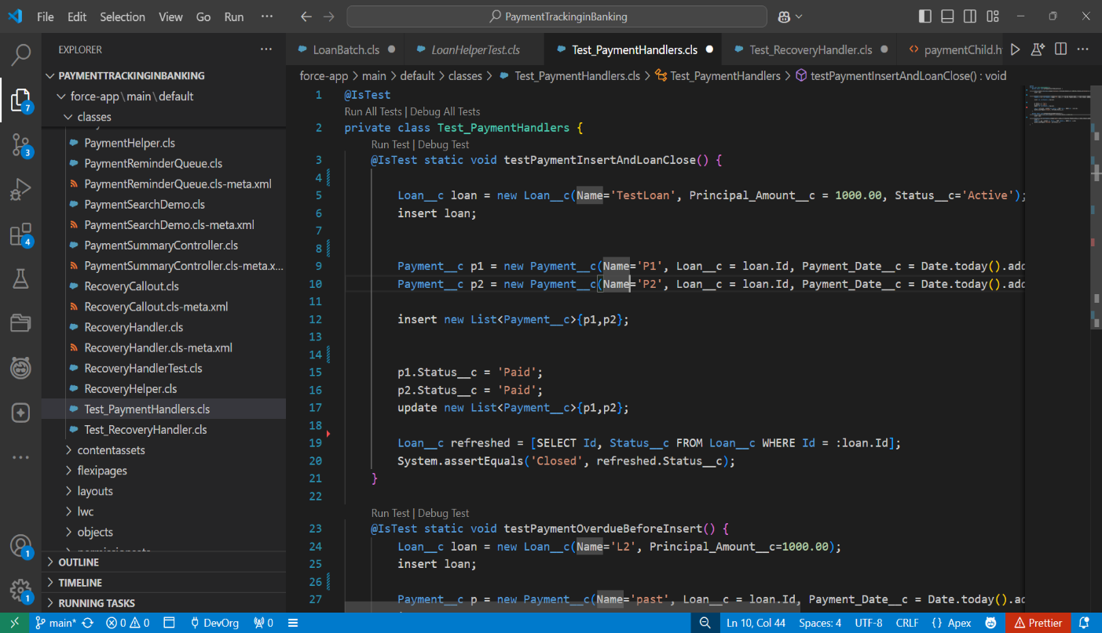

**Test_RecoveryHandlers.cls**

@IsTest

private class Test_RecoveryHandler {

    @IsTest static void testRecoveryFailsOnNegativeAmount() {

        Recovery__c r = new Recovery__c(Name='R1', Amount_Recovered__c = -10);

        try {

            insert r;

            System.assert(false, 'Expected DML exception for negative amount');

        } catch (DmlException ex) {

            System.assert(ex.getMessage().contains('Amount Recovered must be greater than 0.'));

        }

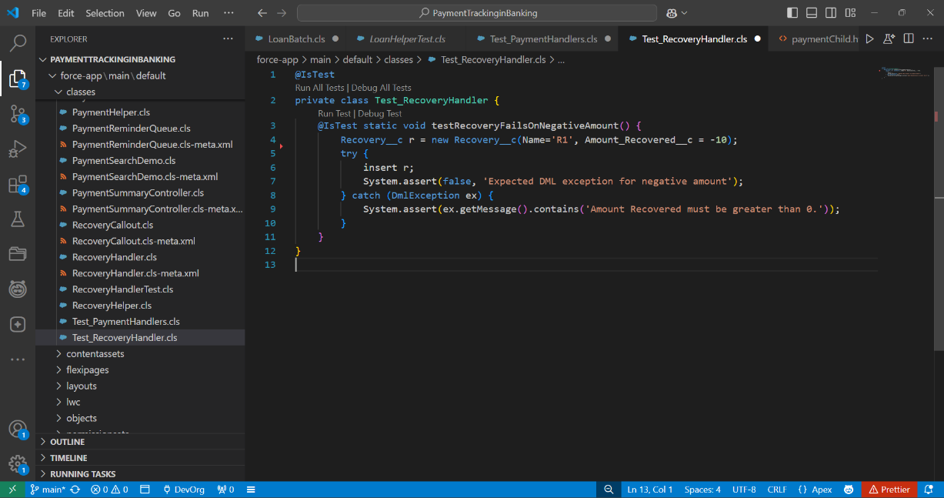    }

}

# Asynchronous Processing

* Combined Batch, Queueable, Scheduled, and Future methods for async operations.

# Phase 6: User Interface Development Lightning App Builder

* Created a custom Loan_Record_Page, Payment_Home_Page, Payment_Record_Page, Recovery_record_Page

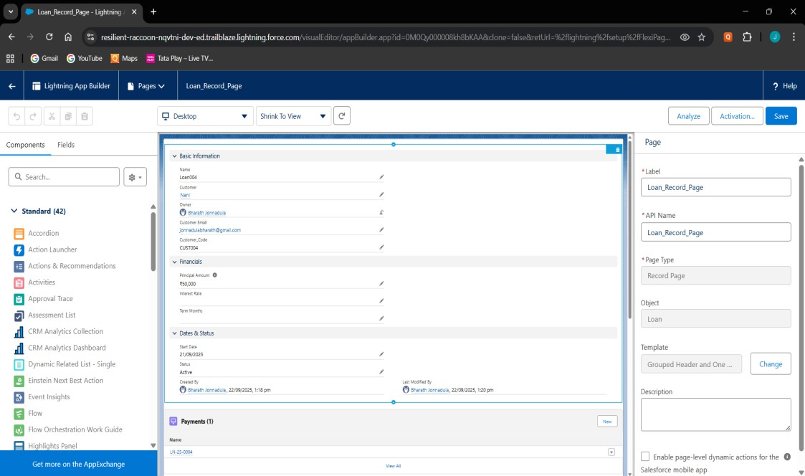

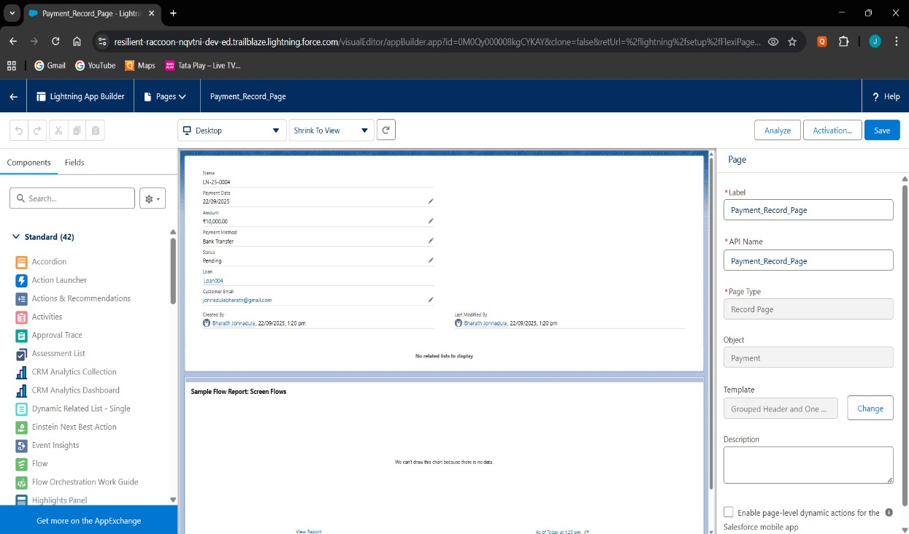

# Record Pages

* Built custom Record Pages for Loan and Payment objects using Lightning App Builder.

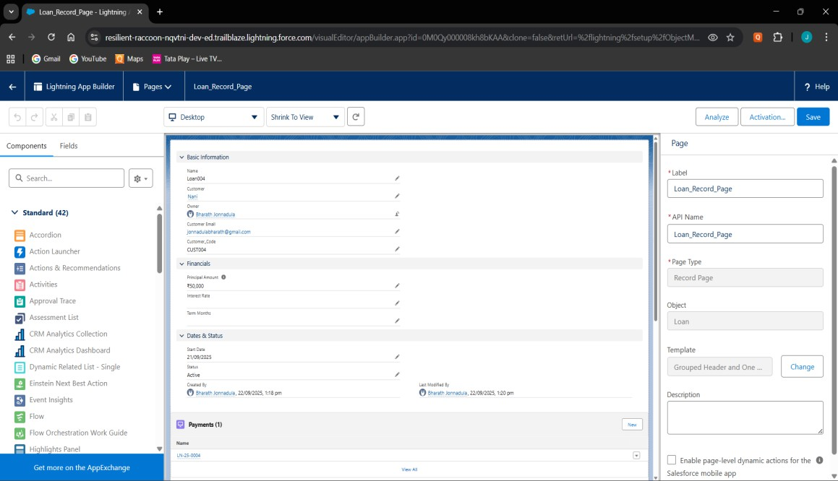

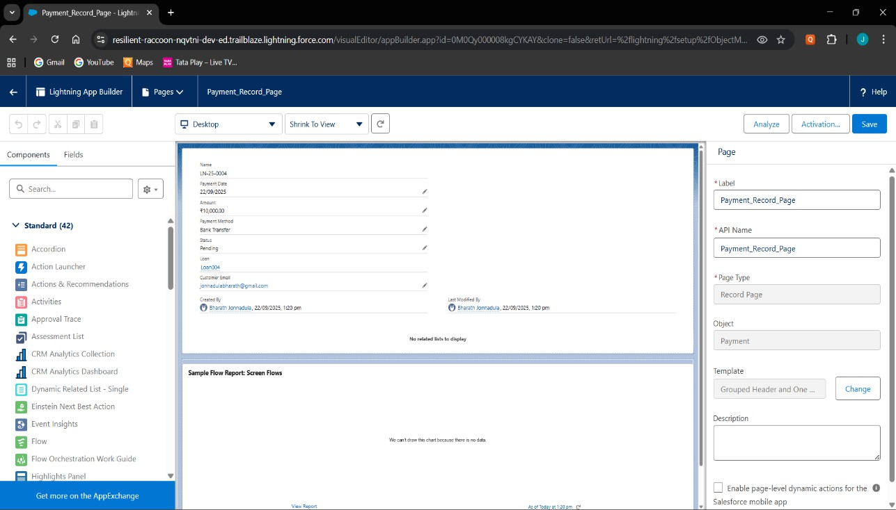

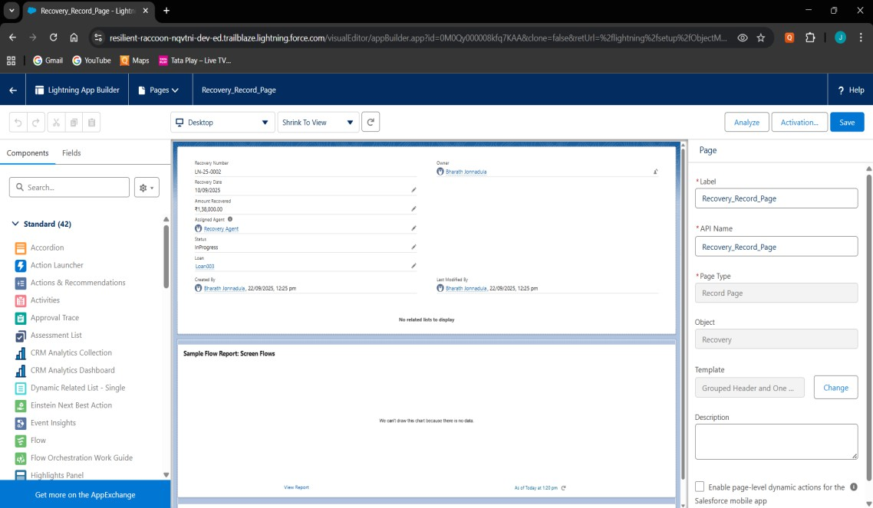

# Tabs

* Added custom tabs for Loan, Payment, and Recovery objects.

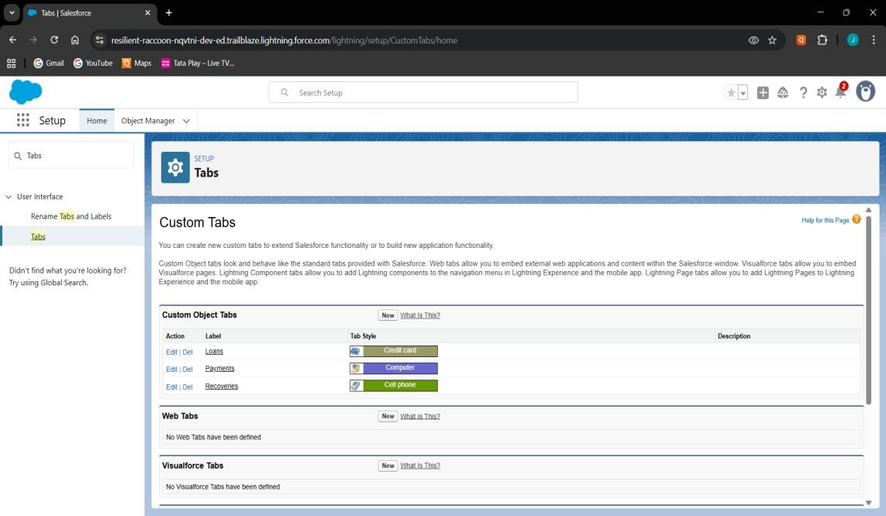

# Home Page Layouts

* Customized the Home Page with components like Recent Loans, Pending Payments

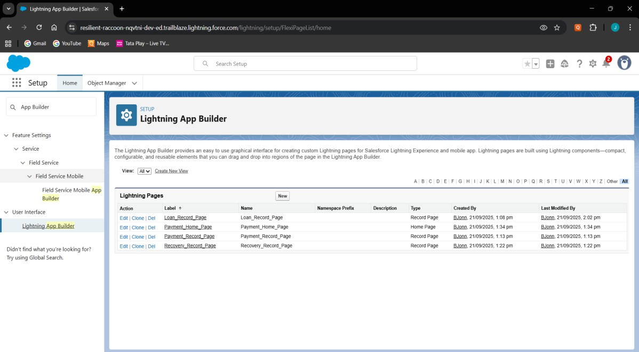

# Utility Bar

* 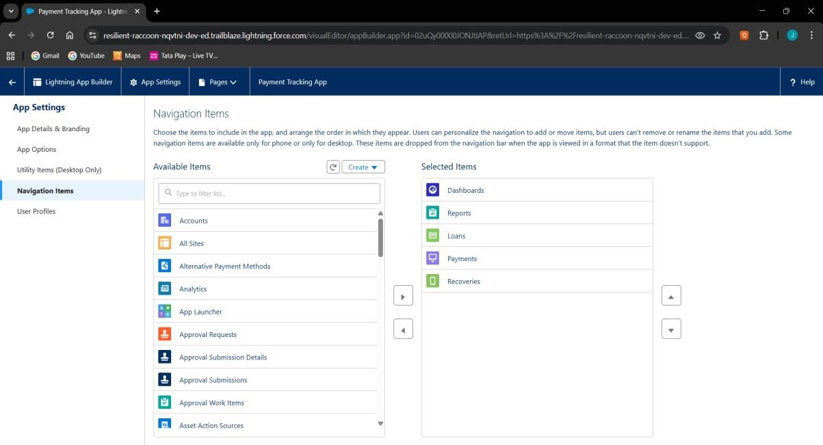Switch between loan & payment records.

# LWC (Lightning Web Components)

* Built LWC components (loanSummary, loanDetails, paymentChild).

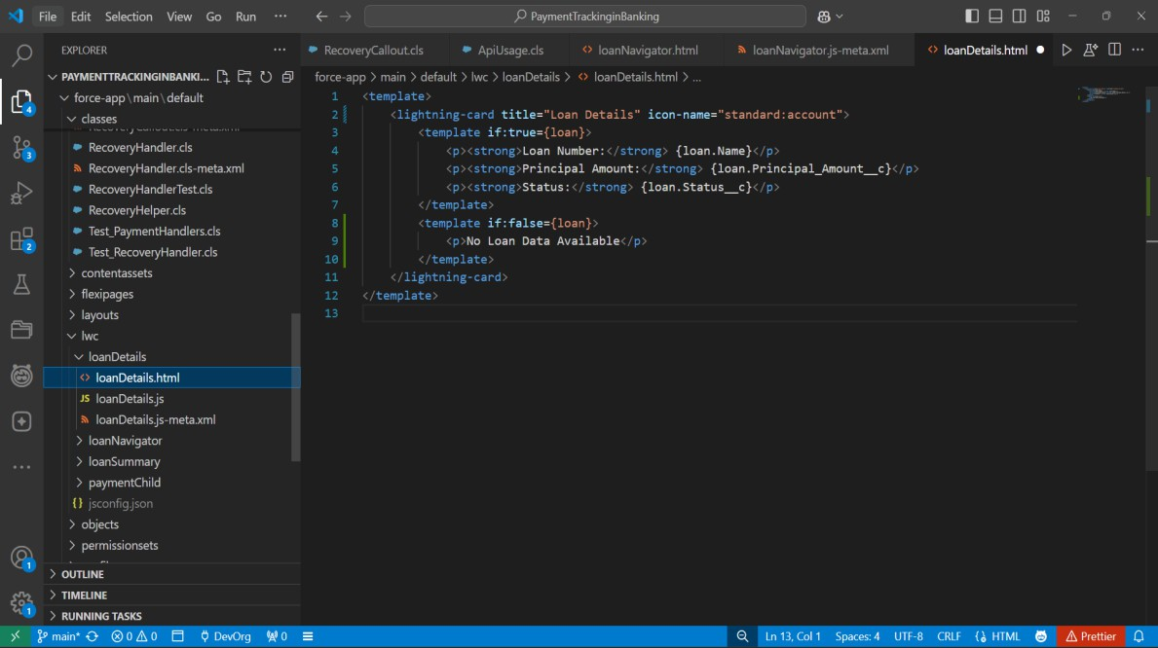

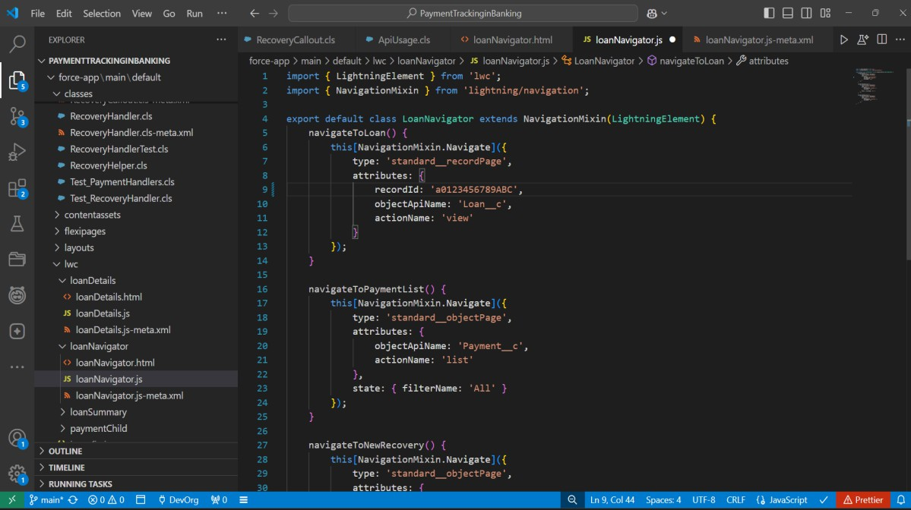

# Wire Adapters

* Used @wire(getRecord) to fetch Loan fields directly in LWC.

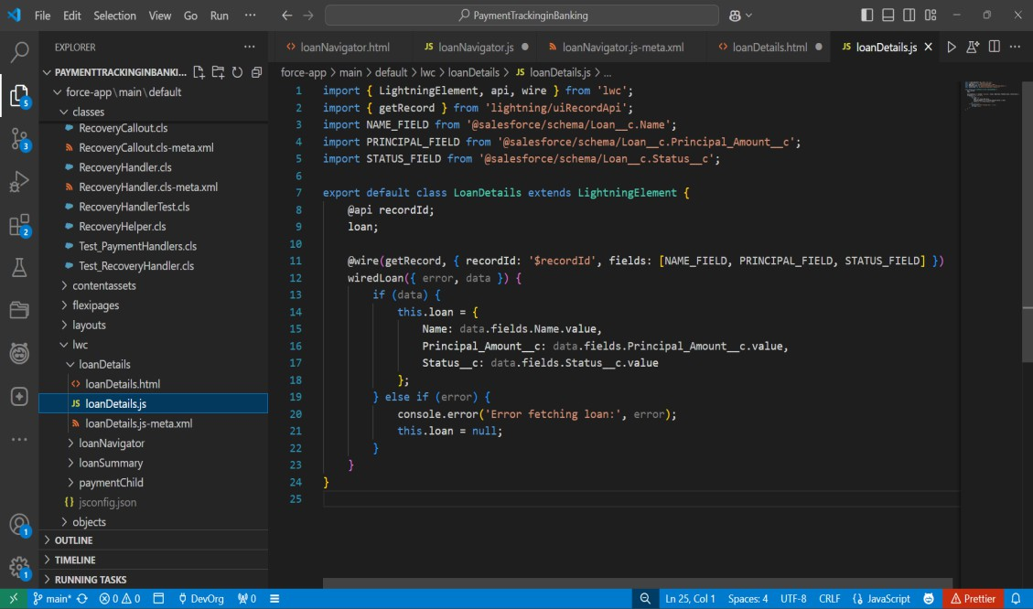

# Navigation Service

* Implemented NavigationMixin to let users navigate from Payment

→ Loan detail page.

* Improves user experience with one-click record redirection.

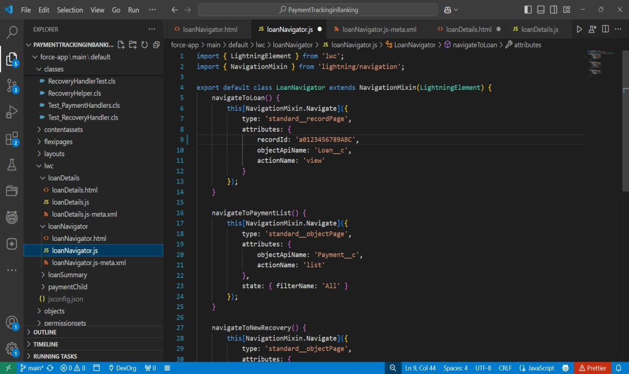

# Phase 7: Integration & External Access Named Credentials

* Used to securely store API endpoints + authentication details for external systems.

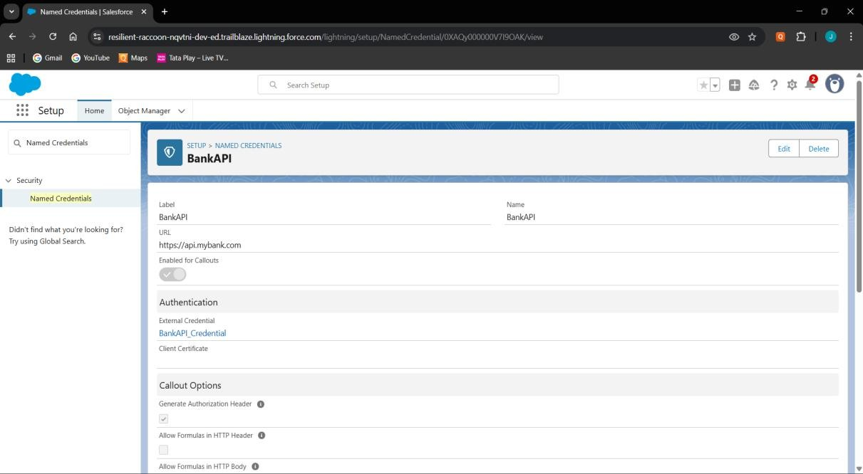

# External Services

* Lets Salesforce call external APIs using schema (Swagger/OpenAPI).

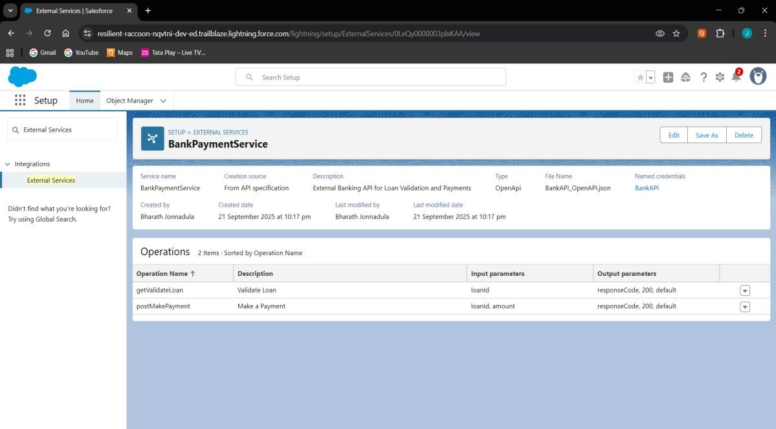

# Web Services (REST/SOAP)

* Allow external system to fetch Loan details.

**LoanExternalService.cls**

public with sharing class LoanExternalService {

    public static String getLoanValidation(String loanId) {

        HttpRequest req = new HttpRequest();

        req.setEndpoint('callout:BankAPI/validateLoan?loanId=' + loanId);

        req.setMethod('GET');

        Http http = new Http();

HttpResponse res = http.send(req);

if (res.getStatusCode() == 200) {

            return res.getBody();} else {

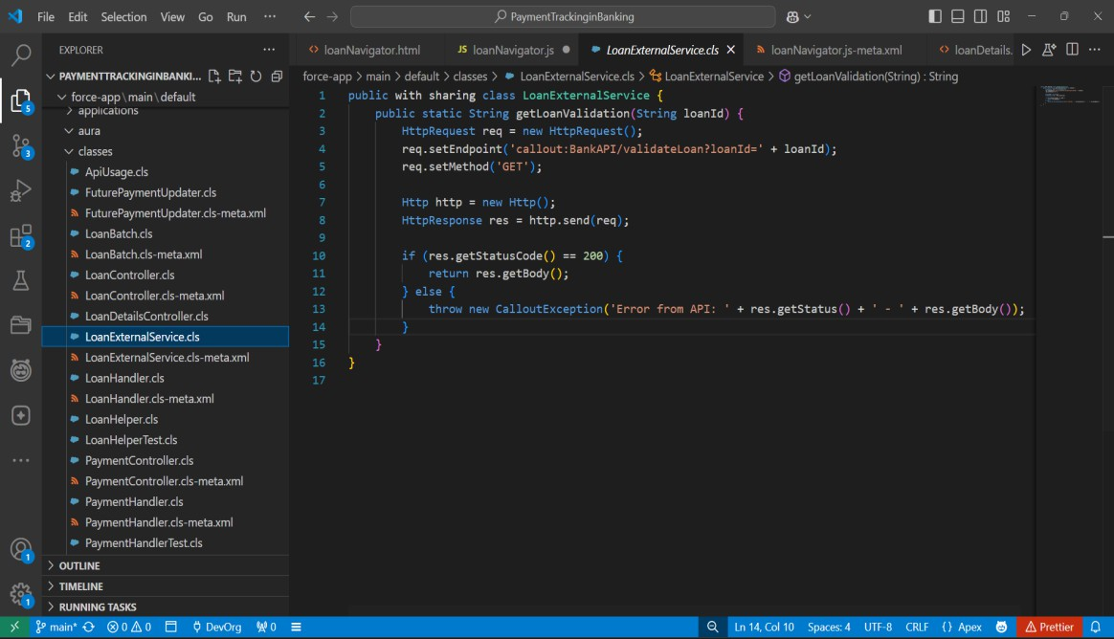            throw new CalloutException('Error from API: ' + res.getStatus() + ' - ' + res.getBody());}}}

# Callouts

* Used when Salesforce sends data to external services.

**RecoveryCallout.cls**

public class RecoveryCallout implements Queueable, Database.AllowsCallouts {

    private Id recoveryId;

    public RecoveryCallout(Id recId) { this.recoveryId = recId; }

    public void execute(QueueableContext qc) {

        Recovery__c rec = [SELECT Id, Loan__c, Amount_Recovered__c FROM Recovery__c WHERE Id=:recoveryId];

        HttpRequest req = new HttpRequest();

        req.setEndpoint('callout:BankAPI/recoveryStatus');

        req.setMethod('POST');

        req.setHeader('Content-Type', 'application/json');

        req.setBody(JSON.serialize(rec));

        HttpResponse res = new Http().send(req);

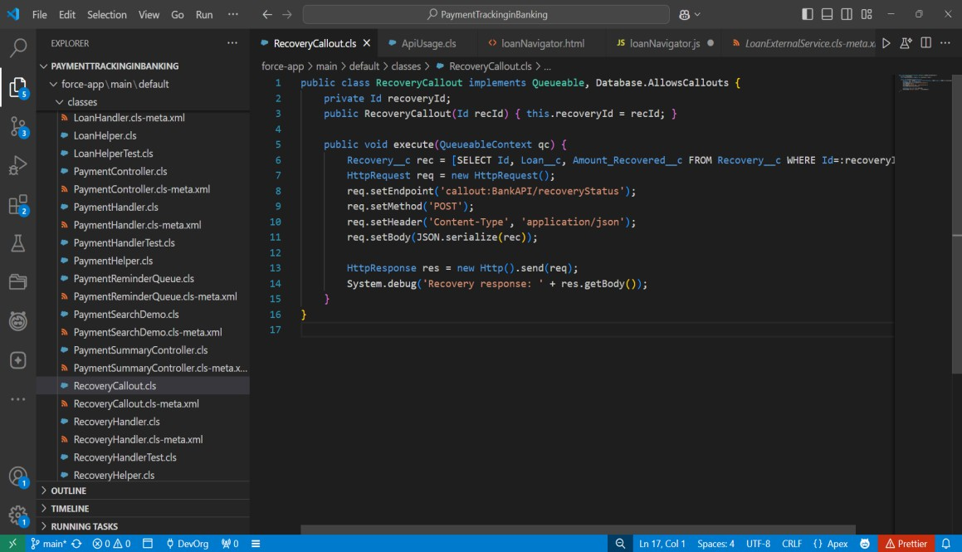        System.debug('Recovery response: ' + res.getBody());}}

# Platform Events

* Publish event when a Payment is Overdue (integrates with external collectors).

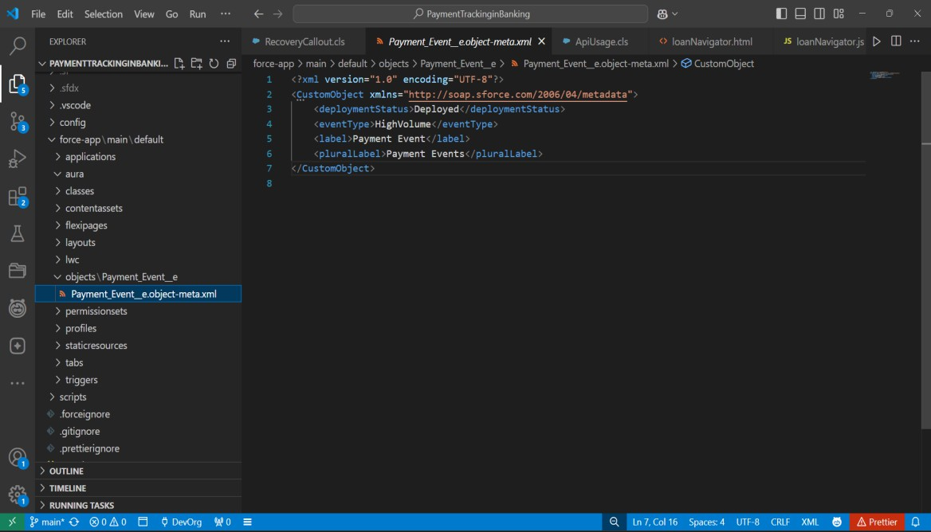

# Change Data Capture (CDC)

* Streams real-time changes of Salesforce records to external systems.
* Any update in Payment_c record can be pushed automatically to reportin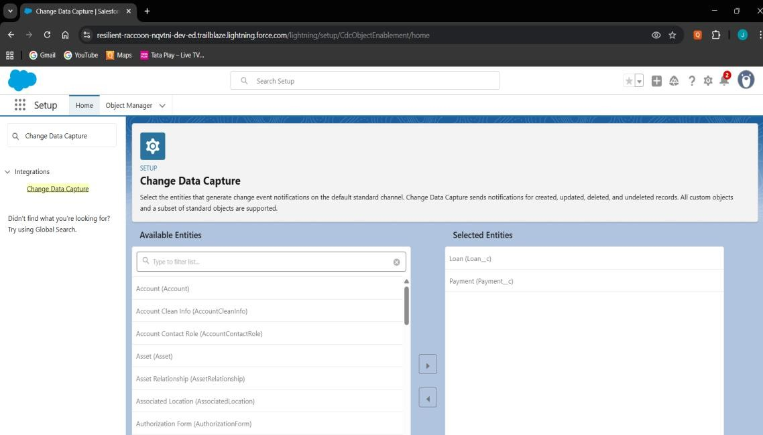g system.

# Salesforce Connect

* ****Provides real-time view of external data without storing in Salesforce.

# OAuth & Authentication

* 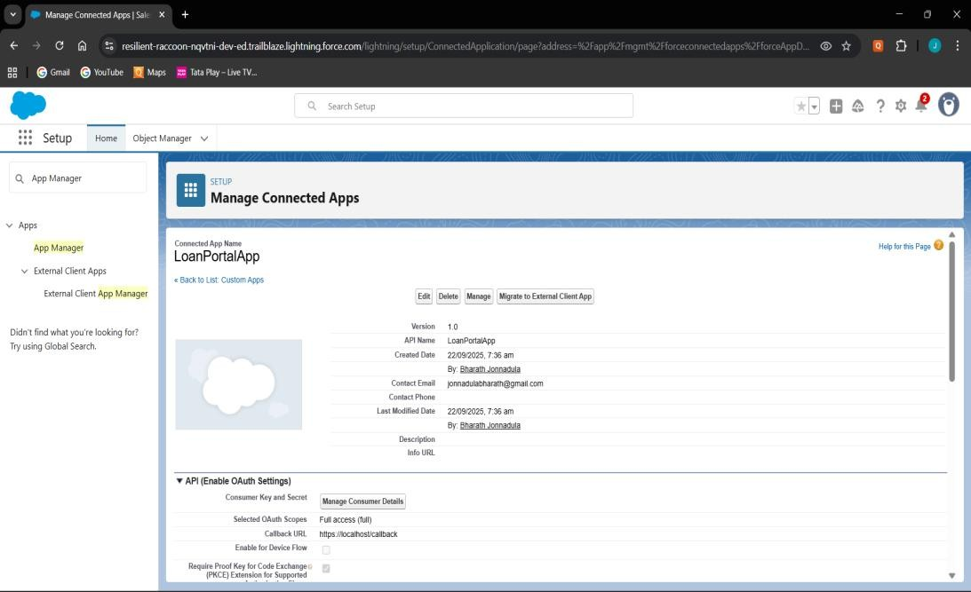Enables secure access for external apps to Salesforce APIs.

# Remote Site Settings

* Required to allow outbound callouts to untrusted domains.
* Add https://api.bank.com as a Remote Site Setting before making callouts.

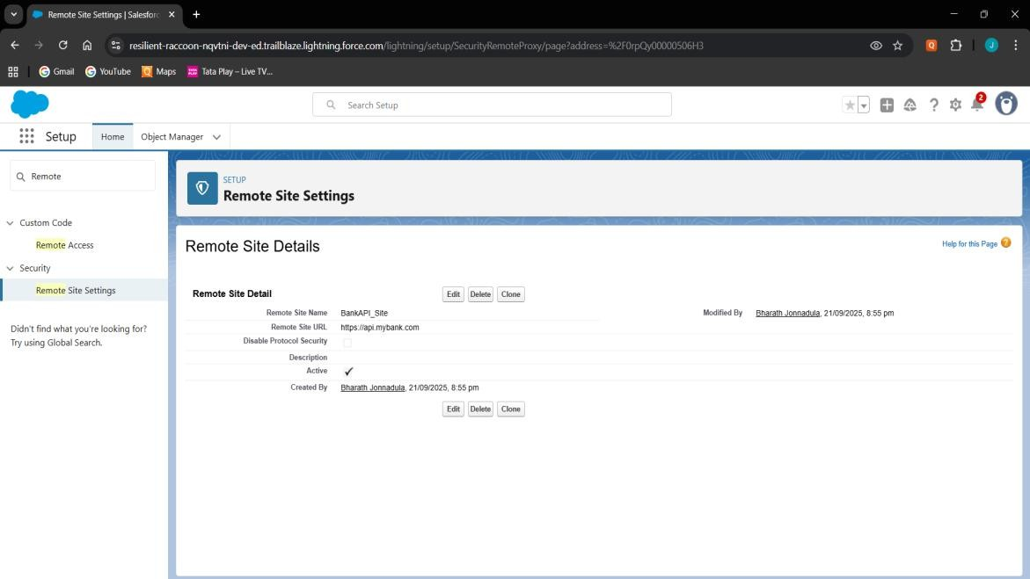

# Phase 8: Data Management & Deployment Data Import Wizard

* Used Data Import Wizard to insert sample data into Loan, Payment, and Recovery objects.

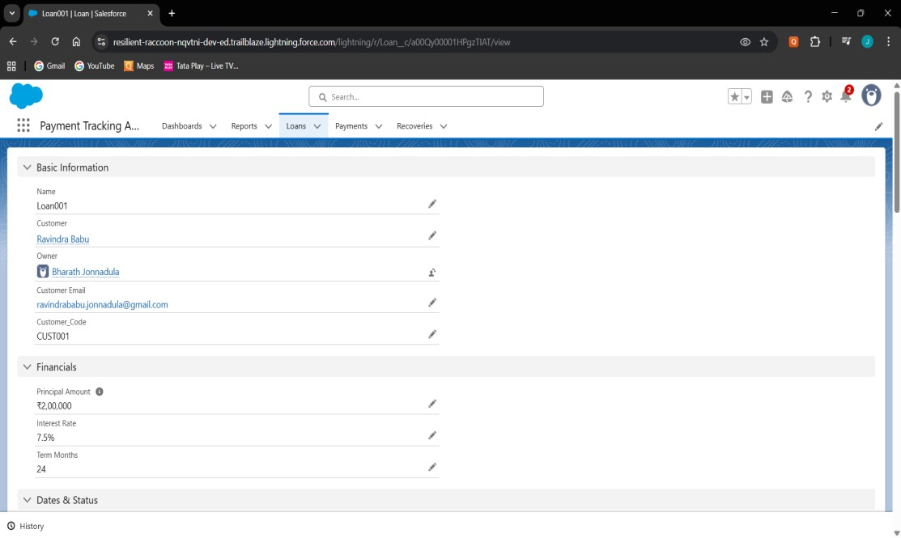

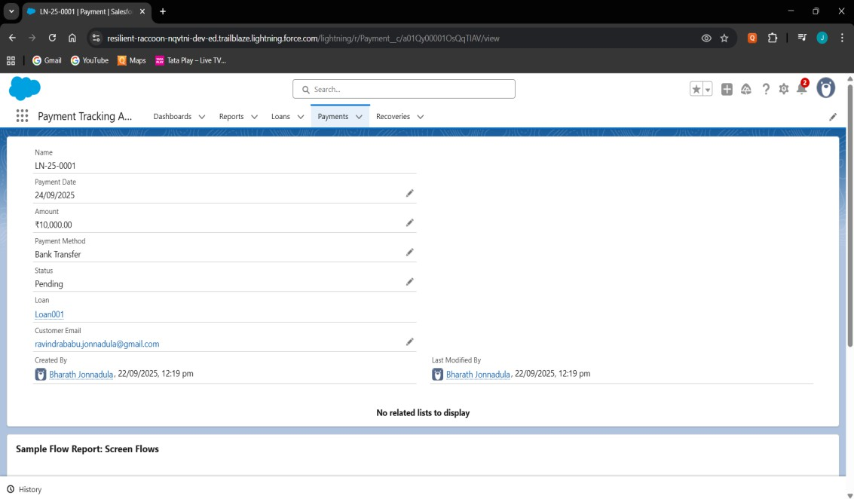

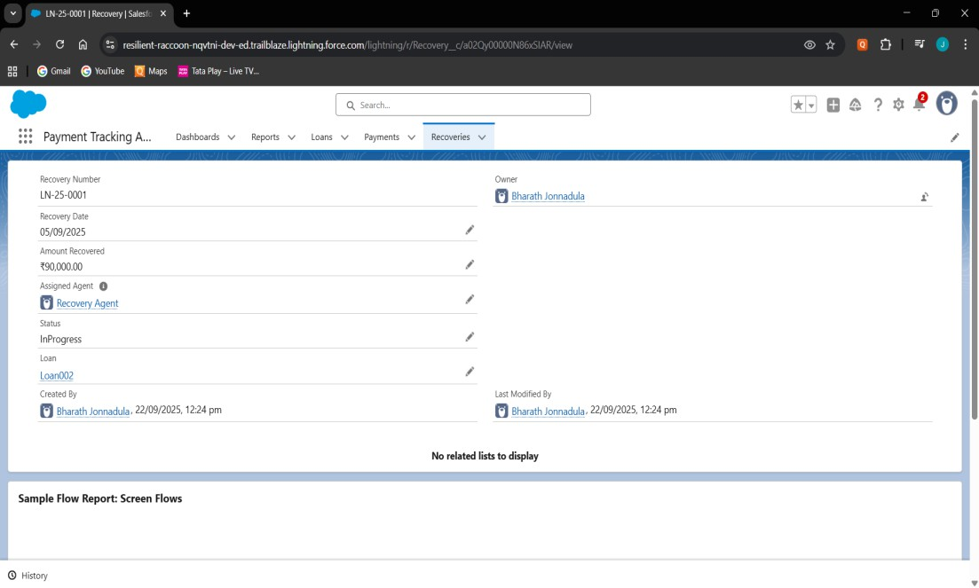

# Data Loader

* Data Loader for bulk upload, but not required since records were limited.

# Data Export & Backup

* Verified Data Export option in Setup for backup.

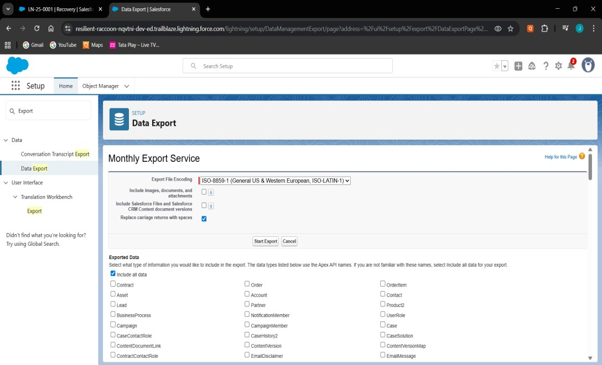

# VS Code & SFDX

* Used VS Code with SFDX CLI for writing and deploying Apex Classes, Triggers, and LWC.
* 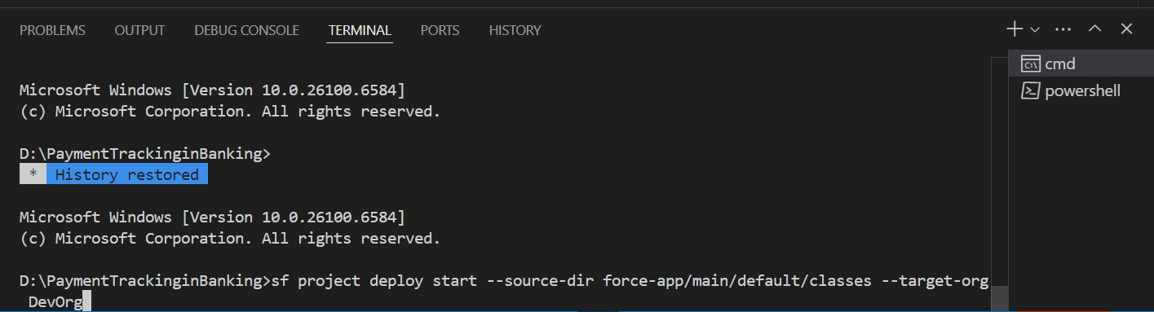Successfully pushed/pulled metadata between local project and Salesforce Org

# Phase 9: Reporting, Dashboards & Security Review

**Reports (Tabular, Summary, Matrix, Joined)**

* + 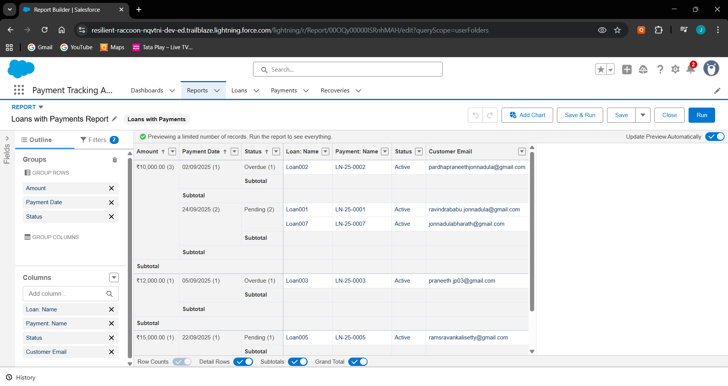Created different report formats (Grouped using Amount, Payment Date, Status and added columns Loan:Name, Payment:Name, Status, Customer Email)

# Report Types

* + Defined a Custom Report Type with Loan__c as the primary object and Payment__c .

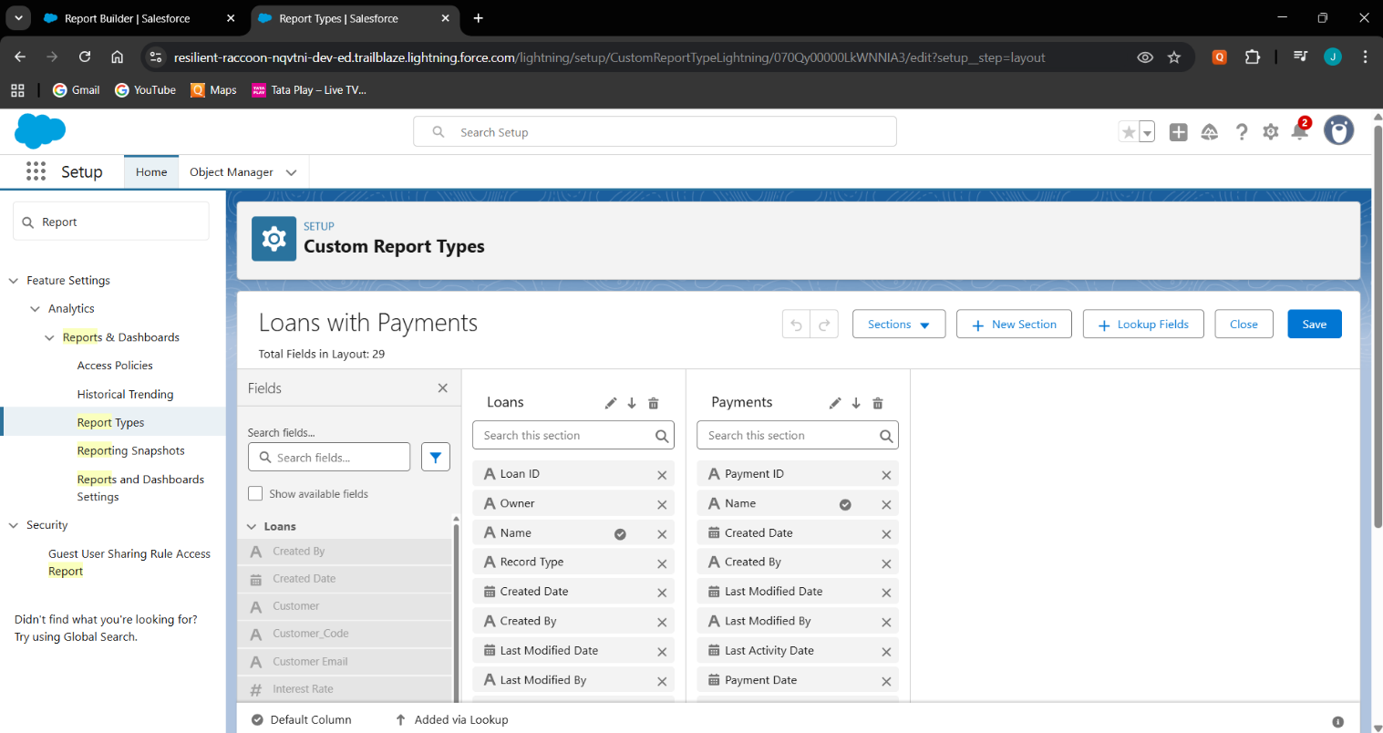

# Dashboards

* + Built a Payment Tracking Dashboard that included widgets like Loan vs Paid Amount.
  + 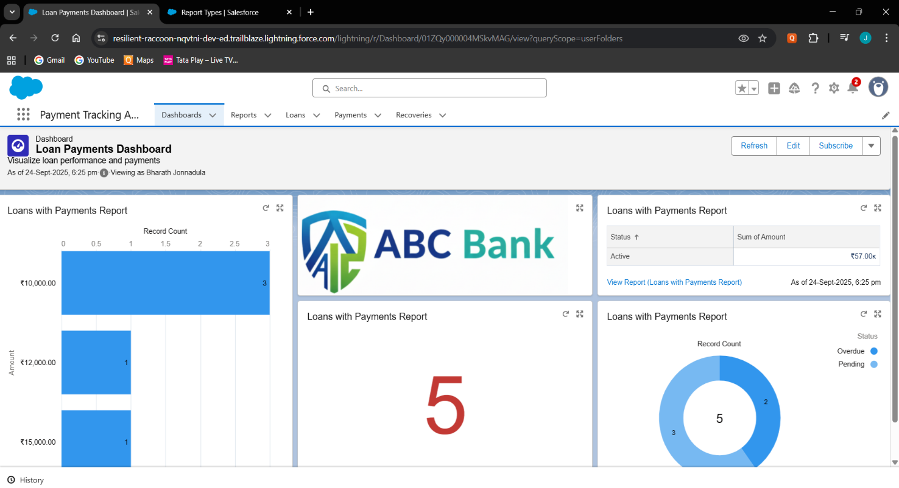Connected each widget to source reports.

# Profiles

* + 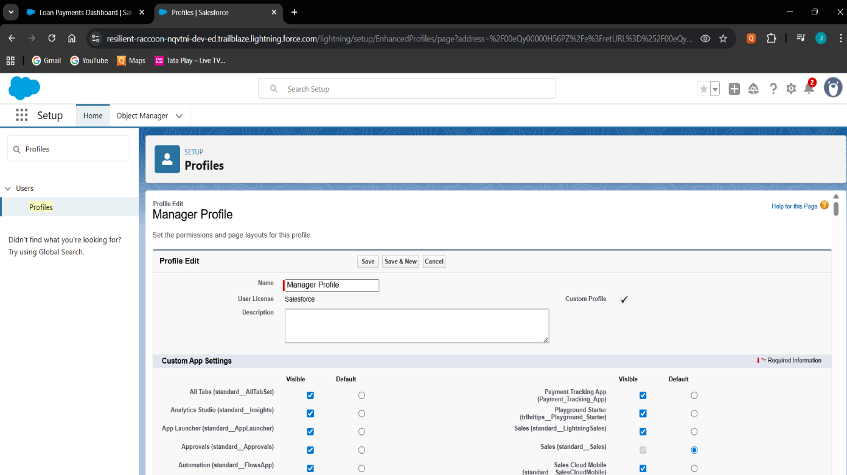Created Manager, Loan Officer, Recovery agent profiles.

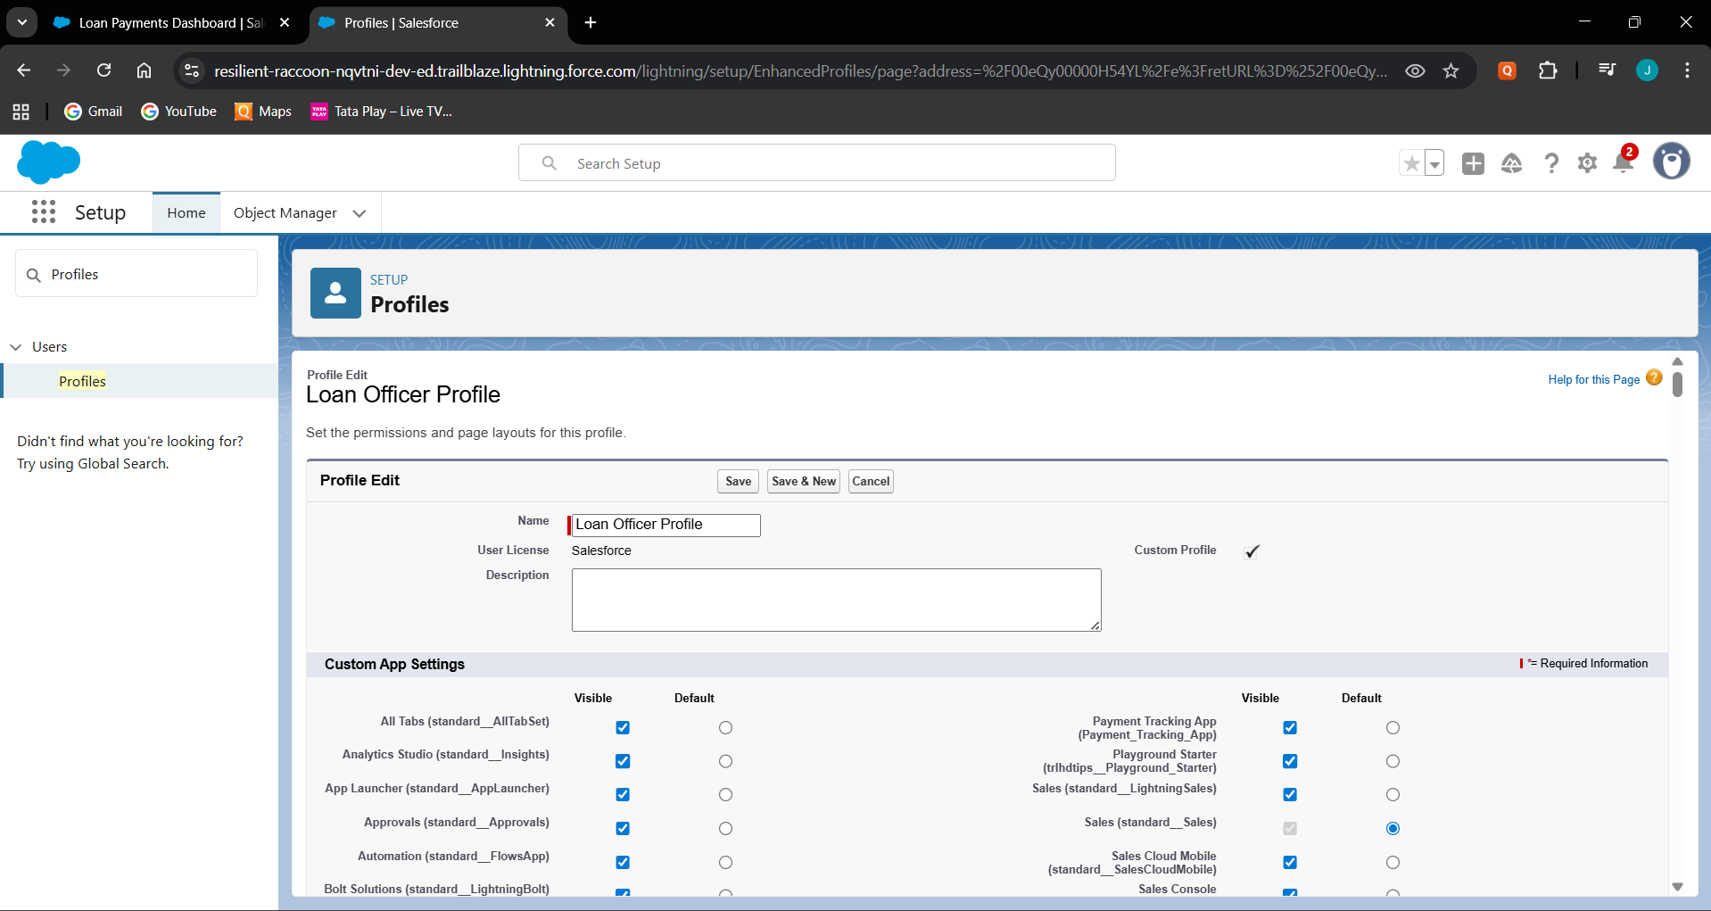

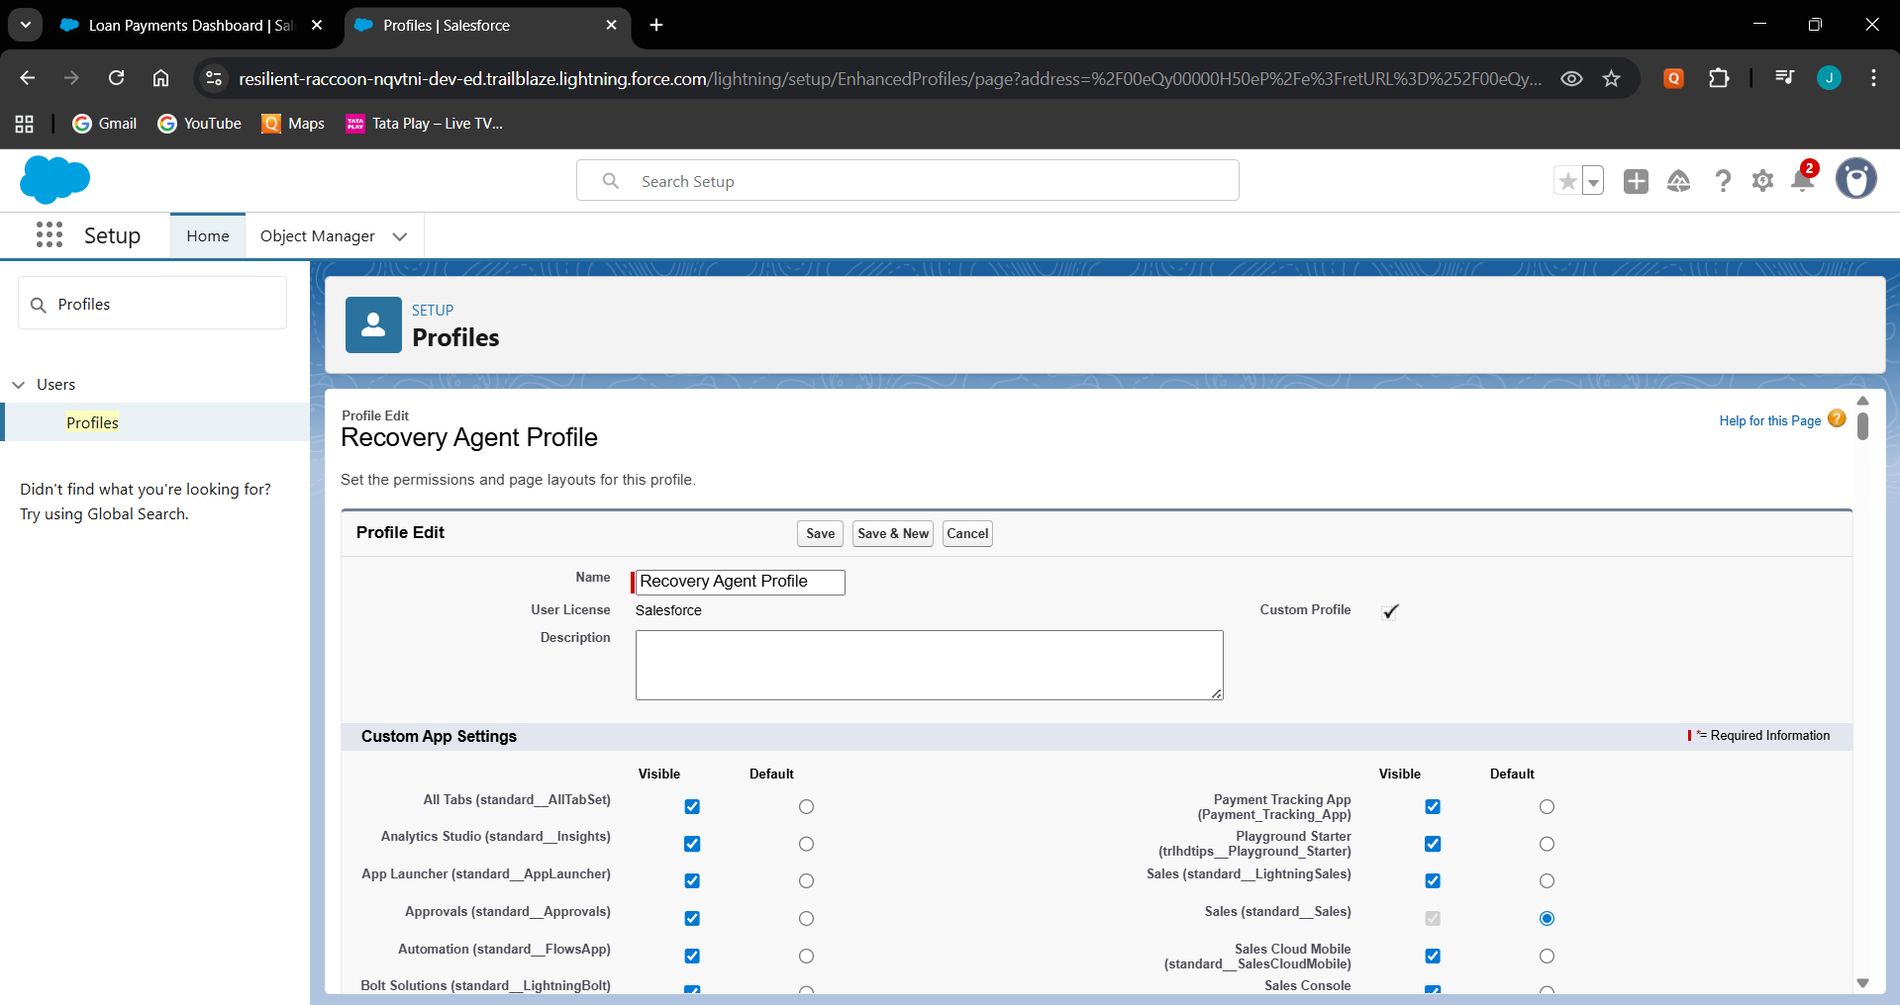

# Roles

* + 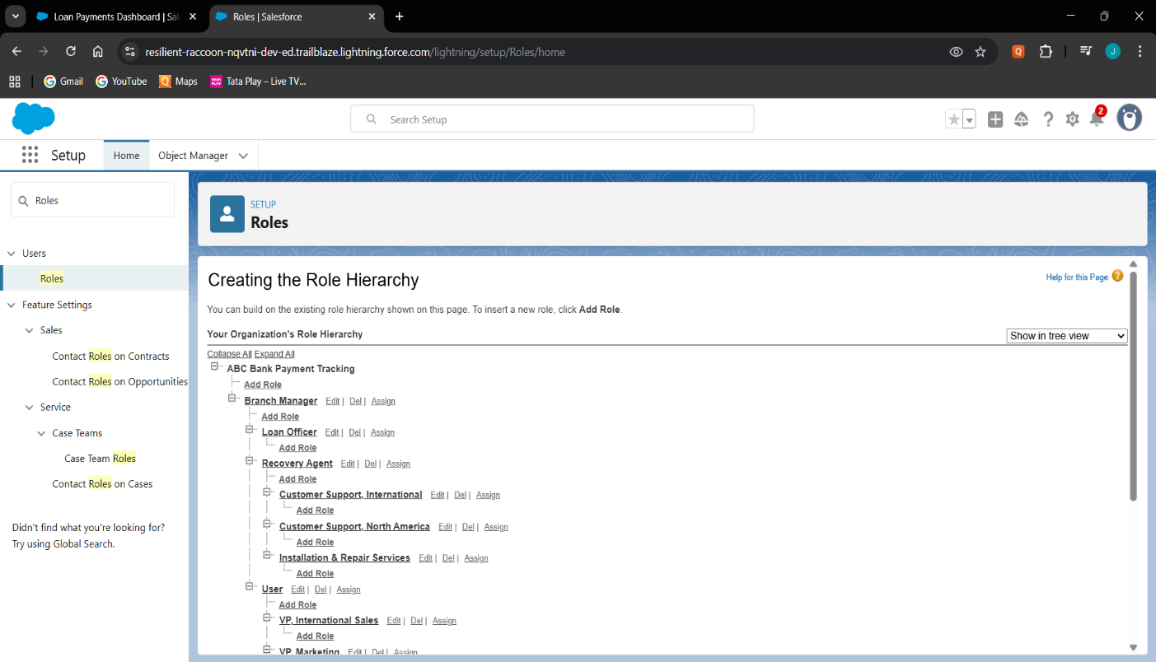Built the role hierarchy of Branch Manager, Loan Officer and Recovery Agent.

# Users

* + 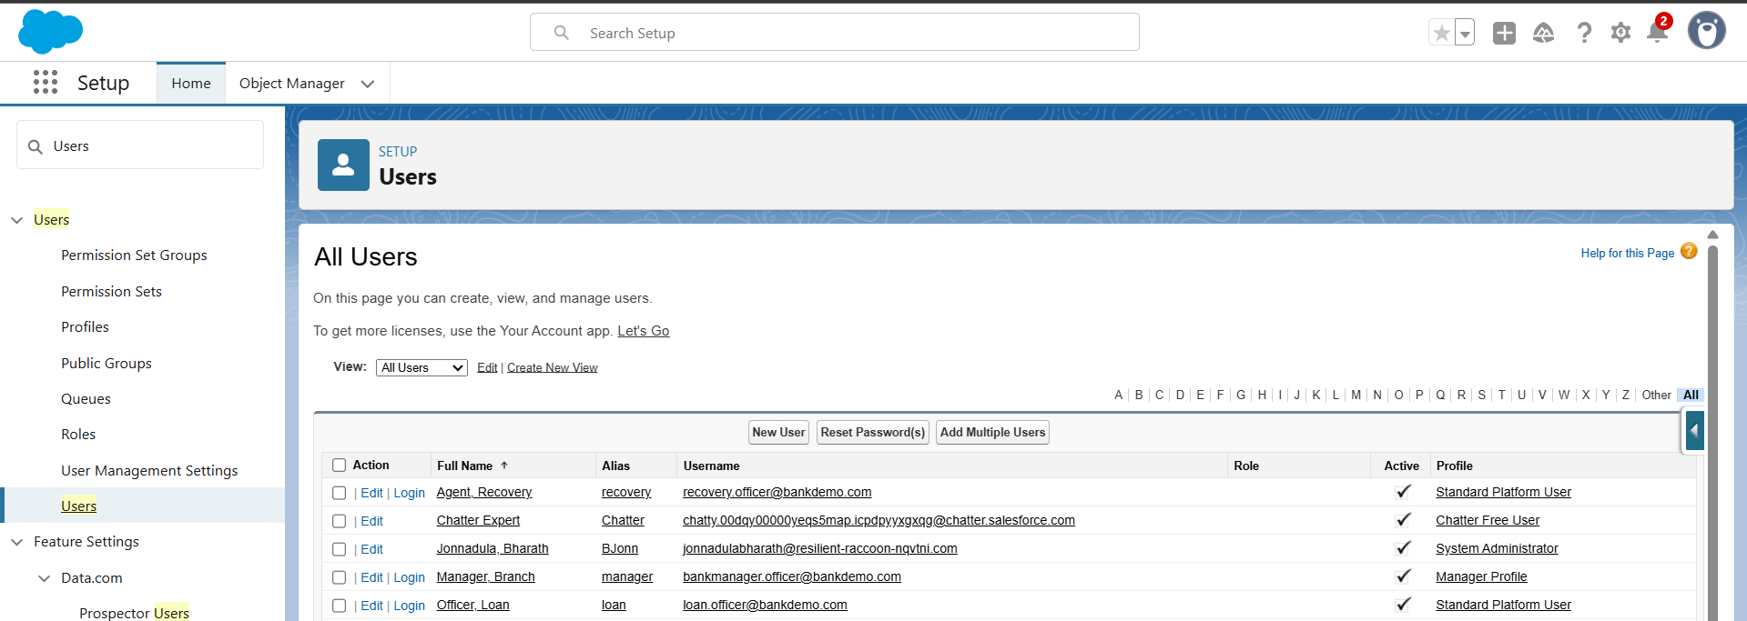Created users (Branch Manager, Loan Officer, Recovery Agent).

# Permission Sets

* + 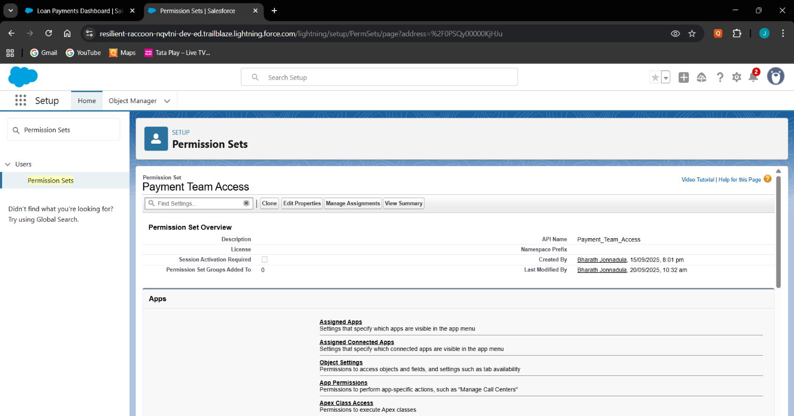Create a Permission Set for payment tracking access.

# OWD & Sharing Rules

* + Set custom objects (Loan, Payment, Recovery) to Private.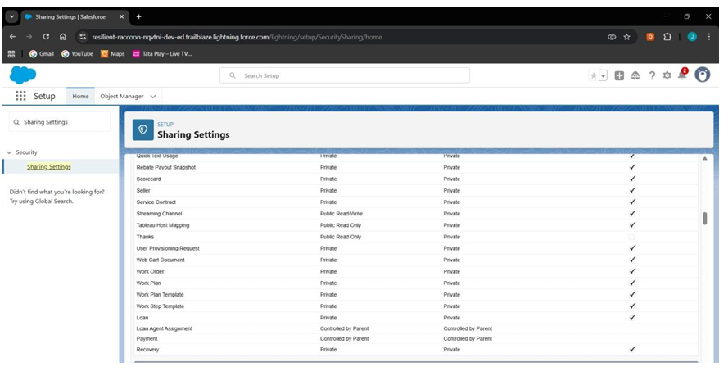

# Sharing Settings

* + 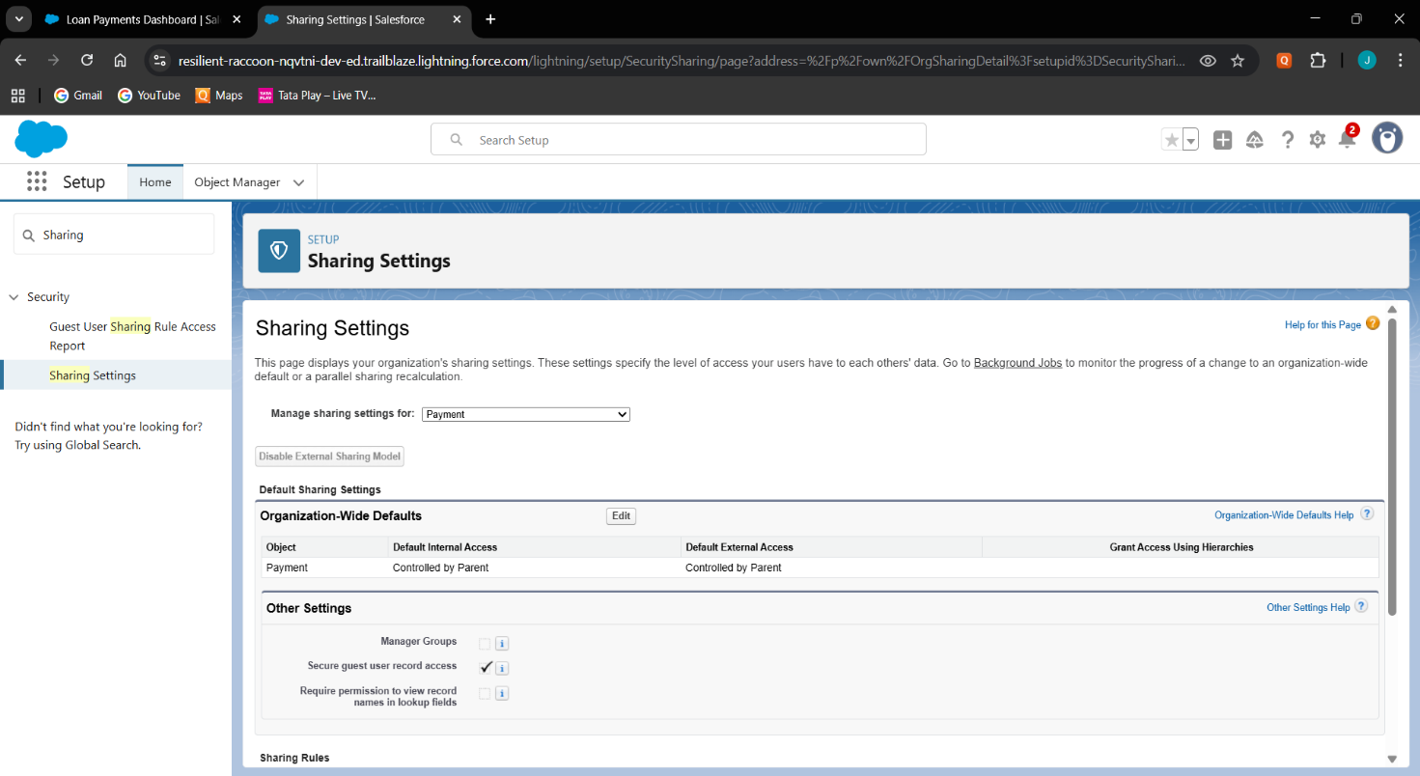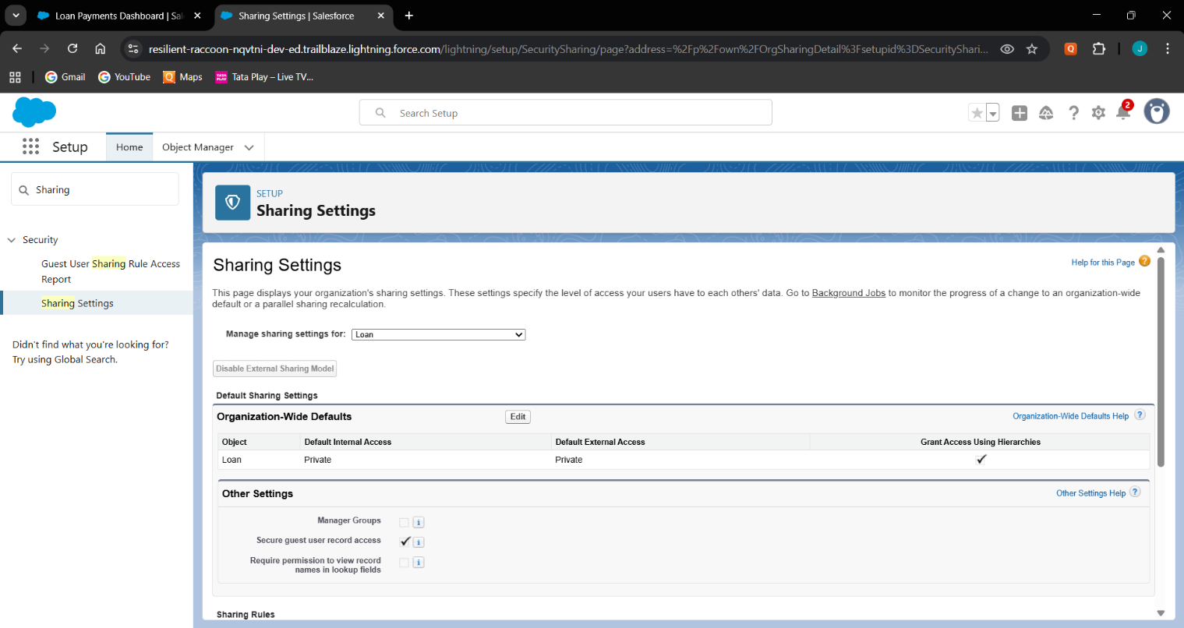Set custom objects to private(Loan, Payment, Recovery).

# Field Level Security

* + Restricted interest rate to view only for manager.

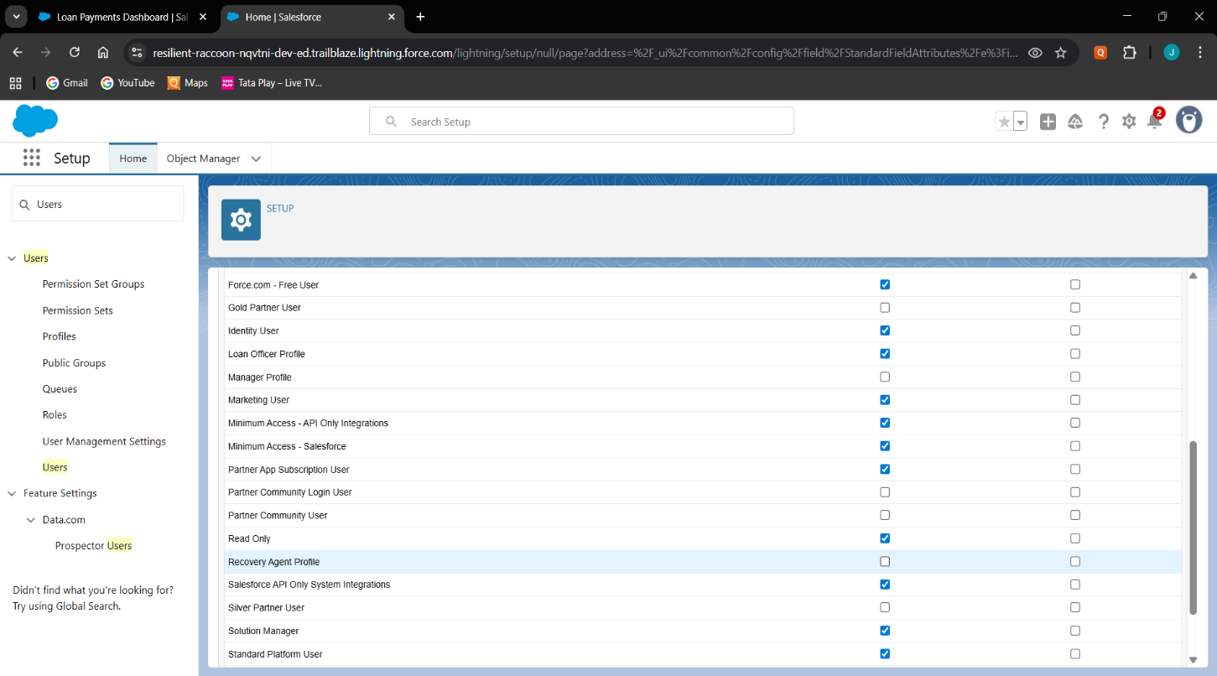

# Session settings

* + 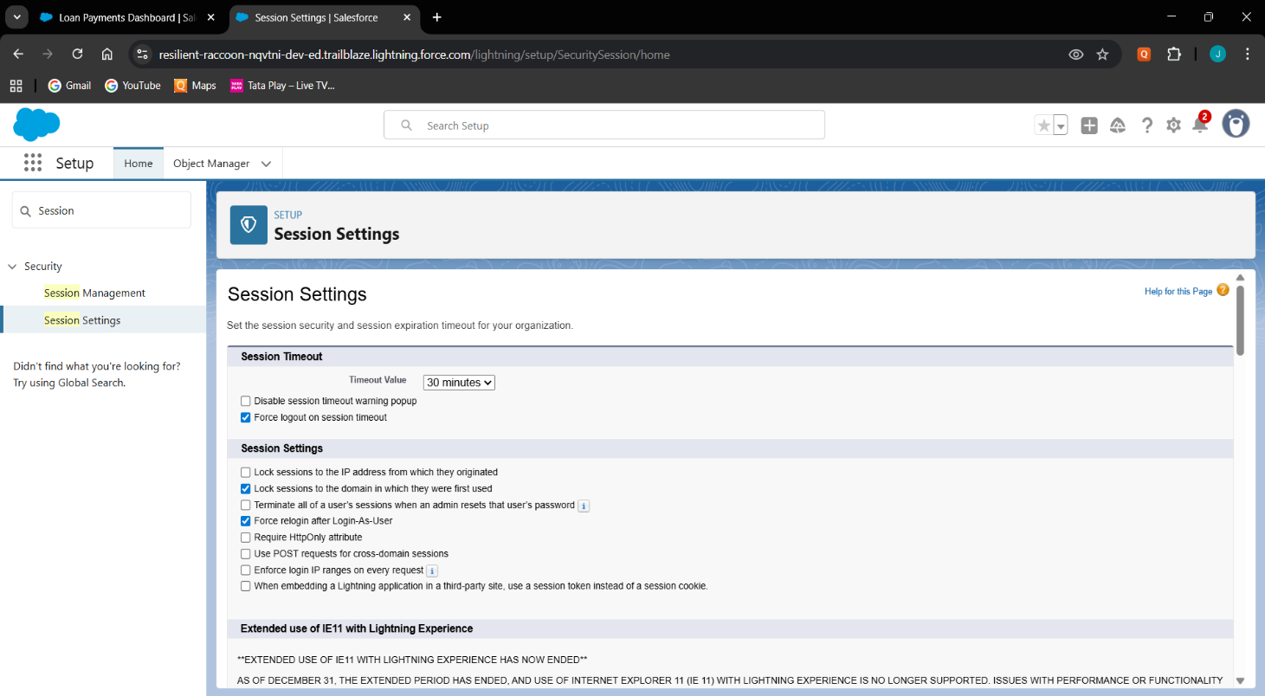Set session timeout for 30 minutes.

# Login IP Ranges

* + 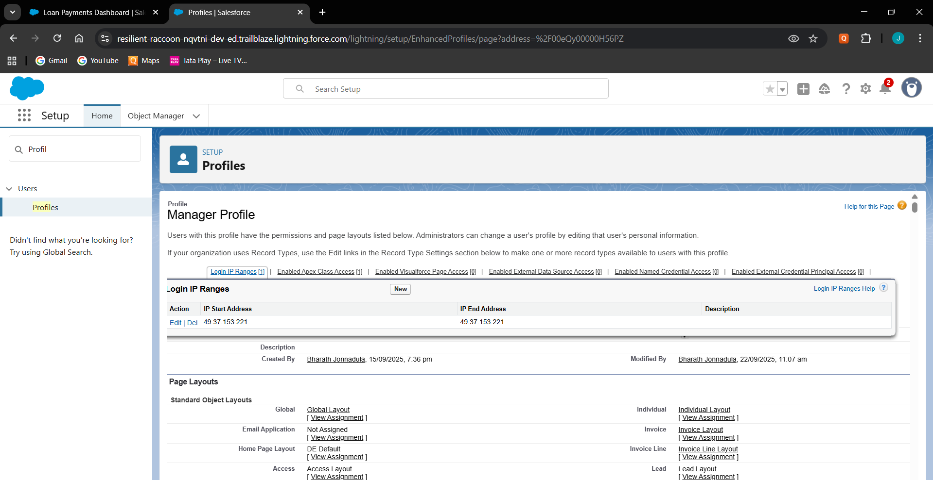Configured login IP ranges for each profile.

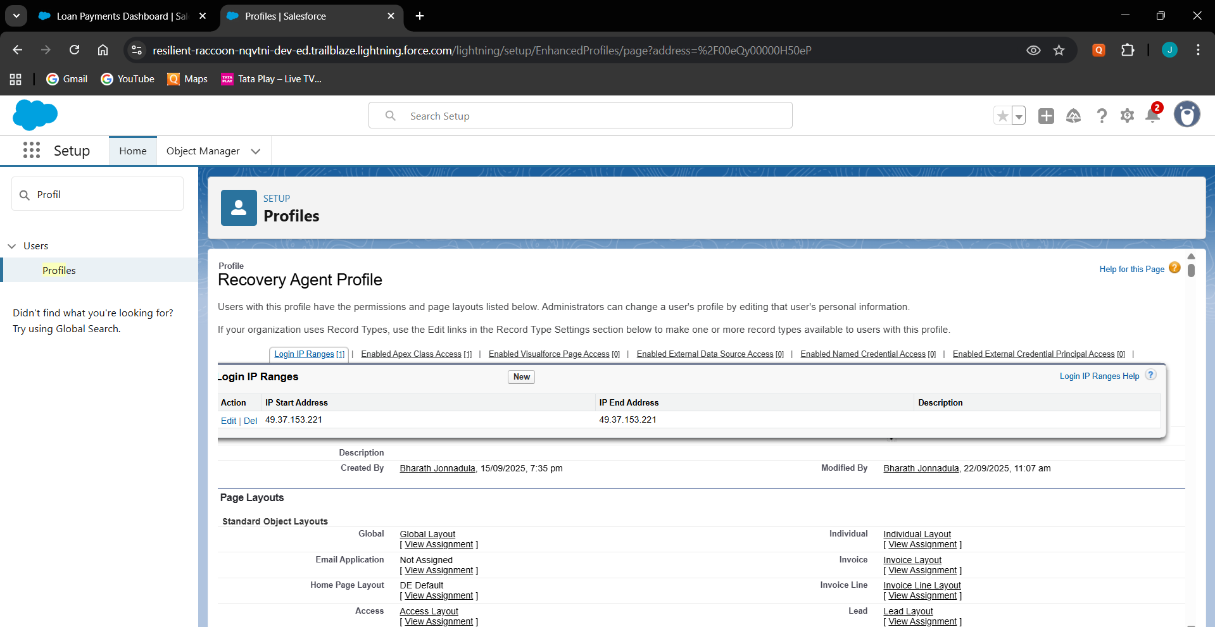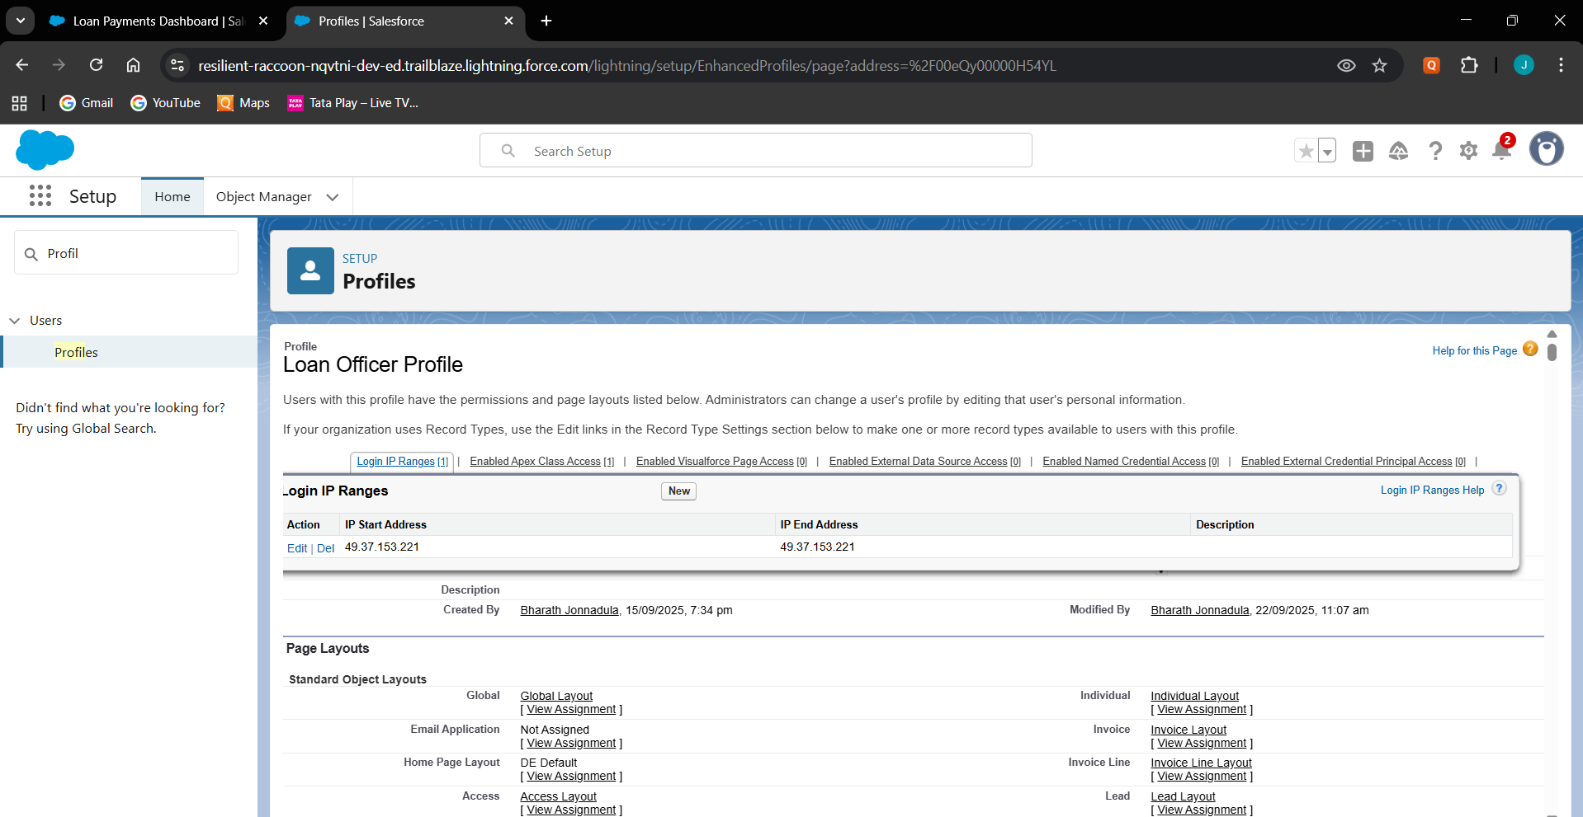

# Audit Trail

* + Enabled Setup Audit Trail to track all admin-level changes.

